**A New You**

Game Design Document

Design Team:

Jesiel “Jezz” Lucena – Head Designer

Thompson Lee – Head Designer

Chaima Jemmali – Test Team

Bohdan Kachmar – Test Team

Cate Malone – Research Team

Dan Acito – Research Team

Jonathan Yang – Mini Games Team

Oles Terletskyy– Mini Games Team

Terry Lei – Mini Games Team

Zihui “Rae” Wu – Mini Games Team

1. **Introduction**

For many of us, it is natural to be in love, get together, and get ourselves into an intimate relationship. But, couples in a loving relationship may not end with a “happily ever after” scenario as expected. In fact, there are some couples whose relationships are twisted in such a way that it is not safe nor healthy for both of them to be together. In such cases, these relationships ended up as “battered relationships”, and it must be dealt with. Afterwards, we need to provide special treatments to the victims of such relationships.

We designed a healing meditation game, called “*A New You*,” that is targeted towards women who had gotten out of battered relationships, and is aimed to provide a long-term self-healing process for those who cannot get into healing groups for various reasons.

The game embarks a light-hearted story plot consisting of several mini-games with activities for the players to play through, each with their own purposes in the healing process. By going through each of the processes the game provides, the players will be able to heal themselves as much as they need to. The game does not need to be played for long or quick sessions, as it is designed to give players the time needed to reflect upon themselves, which is part of the healing process.

The healing process used in some of the mini-games are based on the process described in the book, *Surviving Domestic Violence: A Guide to Healing Your Soul and Building Your Future*, authored by Danielle F. Wozniak and Karen Allen.

1. **Game Purpose**

The purpose of the game A New You is to help the women who were in an abused relationship to recover. The game will provide them a safe environment to reclaim their space, their identity, their power and future. The game will give them enough time to think for themselves and their lives. All of these will contribute to the recovery of their trauma.

* 1. **Experience**

The experience of the game, *A New You*, should be living a happy life without orders or enforcements.

Women inside the game will feel safe and relax. They can do what they want without the fear of being criticized or punished. In this way, they will remind what they like and what they dislike. Also, they will have enough time to think for themselves and slowly realize that they deserve to have all these happiness. Hopefully, we will heal their trauma from inside.

1. **Characters**

## 3.1. Main Character

Main character appears in the game from the very beginning. At first the player needs to customize it. Body shape, hairstyle, skin color, face shape can be chosen from templates. Later main character can be re-customized and dressed up as the player wants. Through the main character the healing process is applied to the player.

Main character can interact with the environment and other characters.

## 3.2. Sparky

Sparky is a fictional, expressive, shapeless character. It is non-human, non-animal, genderless creature. Sparky is flying in the air, can talk and interact with you. It reminds of Na’Vi from Legend of Zelda (Figure 1) and JiBO family robot (Figure 2). This is the video showing JiBO interacting with humans (<https://www.youtube.com/watch?v=3N1Q8oFpX1Y>).

Sparky Interacts with the player on daily basis. For instance, every morning it greets player, asks to dress up. Sparky cares about what the player wants to do. It makes compliments for the player. Every day Sparky shows a recap of what happened in the story.

Sparky supports you throughout the game: in living room, bedroom, kitchen, park, groceries. For example, in kitchen it shows you cookbook and suggests some starter recipes. He advises you to do the groceries and then helps you to choose items since he knows what you are going to cook. In bedroom Sparky suggests to freshen-up and compliments the player. In living room the player chooses furniture from catalog together with Sparky. Also Sparky suggests to water the flower in the living room and care about the tree in the park, as well as, he tells you to play with your pet. Sparky joyfully goes with you to meditate in park.



Figure 1: Na’Vi from Legend of Zelda illustration.

  
Figure 2: JiBO family robot.

## 3.3. Neighbors

In game there are three neighbors that you meet. Phoebe, who lives alone across the street and Ross with Rachel who just married and live on the same street with you:

* Phoebe is blonde, tall woman who likes to play the guitar and do yoga.
* Ross is a geologist.
* Rachel is a waitress.

All of them are going to the player’s “move in” dinner. Later the player occasionally meets them in the park.

## 3.4. Pet

There is a pet in the game. Depending on the story and the player’s preferences it can be either a dog or a cat, or a hamster. Sparky is going to introduce the pet to the player. Later in game the player is expected to care about her pet.

## 3.5. Flower

Flower is in the living room. It is just another non-human, non-animal character who the player should care about. Depending on the storyline and player’s preferences it’s visuals can differ.

## 3.6. Tree

Sparky tells you that it is important to plant your own tree in the park because that will make the park greener. Watering the tree becomes the player responsibility. After you successfully make your duties you get a reward - tree becomes bigger and greener.

**4. Core Mechanics**

**4.1. Controls**

The game will be mainly point and click. Players will move the mouse to points of interest on the game screen, and interact by clicking. This will be used to navigate through the town as well as through several mini-game interfaces.

Examples of things the mouse can be used to interact will be:

* Menu Buttons
* NPCs
* Entrances to Buildings
* Interactive objects, such as furniture

Additional Keyboard Controls:

**ESC** – Pause

**SPACE** – Continue Dialogue

Keyboard input will also be used to allow the player to type things, such as their name.

**4.2. Storyline**

This suggested storyline is meant to be very flexible, to the point that the player can either choose anything to do, or continue following the storyline suggested by Sparky.

After Day 1, every time the player starts the game, the avatar should start in the bedroom, with a suggestion from the companion of what to do. Random daily events are shown to the player upon start up. The game saves progress automatically.

This storyline is based on research upon how the progression of healing process should happen after a battering relationship is over.

* Day 1 – Bedroom
* Introduction of the companion
* Introduction of the apartment and bedroom
* The companion suggests that she should Freshen Up
* Try some clothes on and create the avatar
* Compliment her
* Take a picture (reward)

* Day 2 - Living Room
  + The companion suggests that the avatar should dress up for unpacking the furniture in the living room
  + Decoration of the living room
  + Welcoming visit from the neighbors (with cookies)
  + The companion suggests that she should invite the neighbors for a dinner
* Day 3 Option 1 - Kitchen
  + The companion shows you the cookbook and suggests some starter recipes
  + She cooks the preferred recipe
  + The neighbors arrive for the diner and introduces a little story about a common life happening
* Day 3 Option 2 - Park
  + The companion invites you to the park, to relax after this week
  + She meets her neighbor, who introduces a friend
  + The city map is shown for the first time
* Day 3 Option 3 - Groceries
  + The companion tells you that we need to do the groceries, since you cooked the diner for the neighbors
  + In the market, she chooses her favorite items to fill the grocery list and plays the mini game
  + She meets the neighbor’s friend in the line for the cashier, and the friend talks about the diner and tells her that the neighbor got a cold
* Day 6 ~ Day 9  - Random events
  + Series of random events that happen daily
  + Suggestion to change clothes, appearance and move the furniture in the living room
  + She cooks a soup for the neighbor and visits her and the neighbor gives a present for the help
  + The neighbor gets better the next day
  + Meditation
* Day 10 - Find the pet in her doorstep
* Day 11 ~ Day 14 - Random events
  + Take care of the pet
  + Cook different dishes
  + Suggestion to add a new dish to the cookbook and invite the neighbors for a new diner
  + Meditation
* Day 15 - Find a job
  + Get dressed for the job interview
* Day 16 ~ Future - Random events
  + Get promoted in the job or a new job
  + Take care of a flower in the living room
  + Take care of a tree in the park
  + Meditation

**4.3. Storyboards**

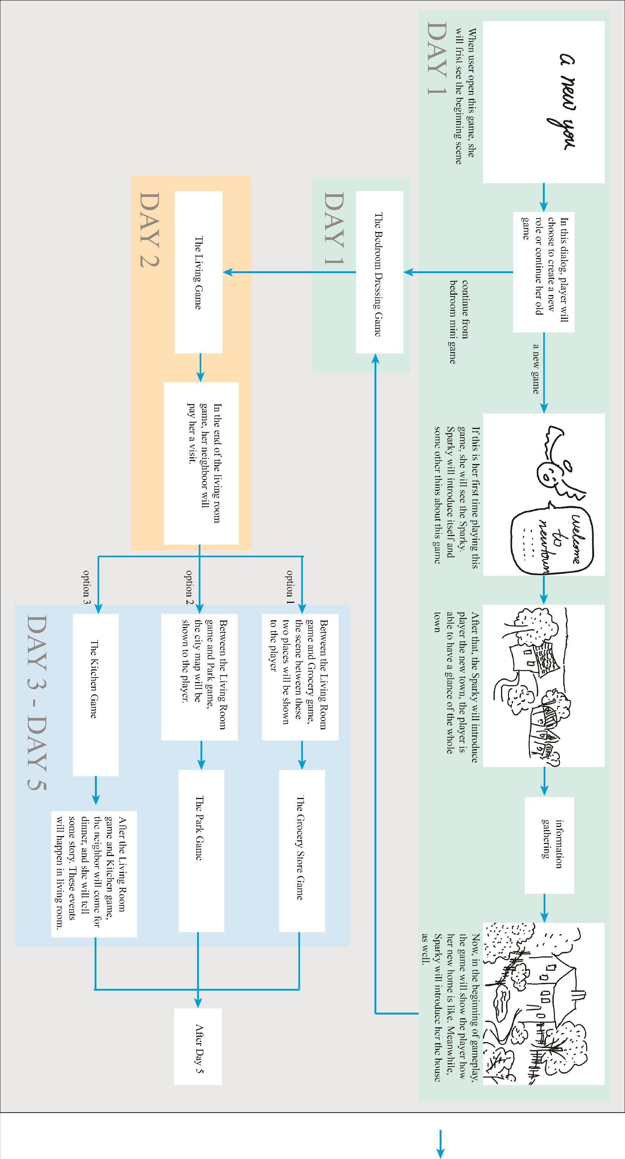

**4.4. Side Quests**

**4.4.1. TV show contests**

Turning on the TV during the game will open a mini-game randomly.

These mini-games are really short and usually consist of one level.

Only one mini-game can be played in a game day.

These are examples of simple mini-games that might be changed or improved.

**4.4.1.1. Timed question mini-game**

**Number of questions:** Usually one per session. (Occasionally we can have special shows with multiple questions and a better prize).

**Walk-through:**

* The player is in the living room and clicks on TV.
* The monitor appears with the two presenters.
* They announce if it’s going to be a question or a riddle.
* When the question appears, the players will have limited time to answer it by clicking on their choice.
* Answer correct: the presenters congratulate and inform the player that the prize will ship soon.
* Answer wrong: the presenters invite the payer to come back tomorrow and try again.

**Remark:** Hints about some questions can be hidden inside conversation with NPCs.

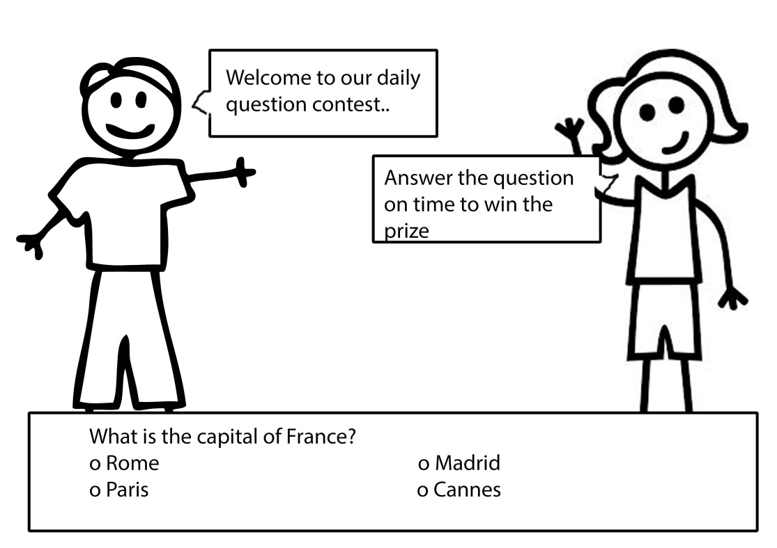

**Figure 4.4.1.1.a. Example layout of the Quiz screen**

**4.4.1.2. Hidden Objects/Find the Differences**

**Number of games:** Always one per session. This game will also be introduced by the presenters

**Walk-through:**

* The presenters introduce what the game is going to be.
* The players will have a certain amount of time to find the maximum of hidden objects/differences between the images.
* The player clicks on the object.
* The player finds all of them: she wins the super prize.
* The player finds enough (certain quota): she wins a less valuable prize.
* The player doesn’t find enough: she is asked to try again tomorrow.

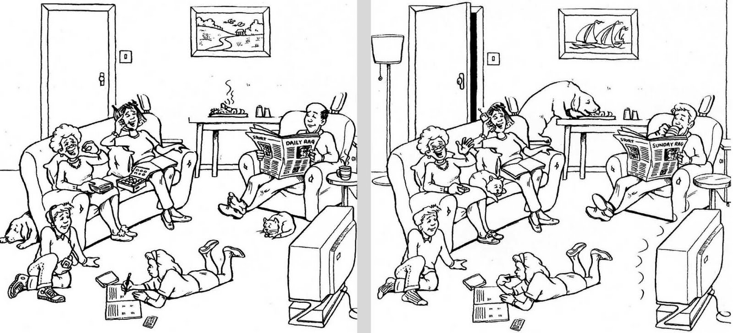

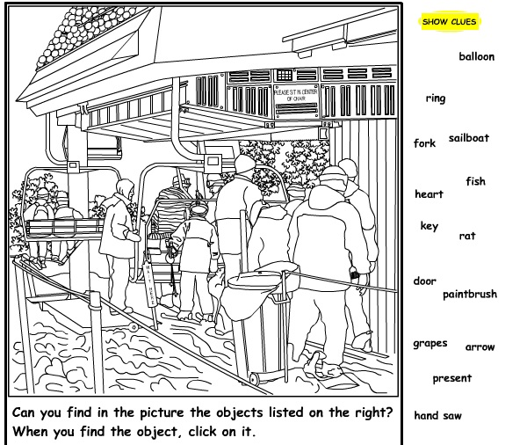

**Figure 4.4.1.2.a. Examples of Hidden Objects/Find the Differences**

**4.4.2. Magazines:**

The player can check the magazine laying on the table. When she clicks on it, she can browse it and find:

* Small articles with positive messages
* Beautiful pictures
* Crosswords
* Sudoku.

**Walk-through:**

* When she clicks on the magazine, it takes the whole screen.
* She can use the arrows to browse it.
* She can click on mini games, images or articles to select them.
* The object selected will be enlarged and centered. If it’s game:
* She can play it for a while and then go back to it later.
* The state of the game will be automatically saved.
* She can get back to it even after quitting the whole game.

**Remark**: Magazine can be renewed weekly or monthly depending on how much content we put in them.

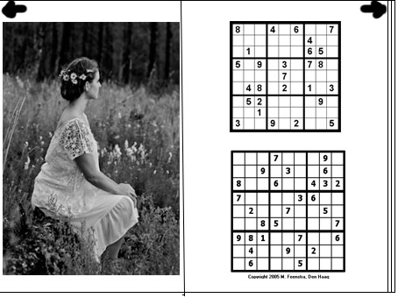

**Figure 4.4.2.a. Example magazine layout.**

**4.4.3. A Little Puppy**

When we are advanced in the game, the player will find a little animal at her front door with a note “Please take care of it, I don’t have enough money to do so”. She will have to:

* Feed it at least once a day.
* Play with it.
* Take it for walks.
* Take it to the veterinary.
* The puppy will grow up slowly.

**Reference:** *Harvest Moon: Friends of Mineral Town*.

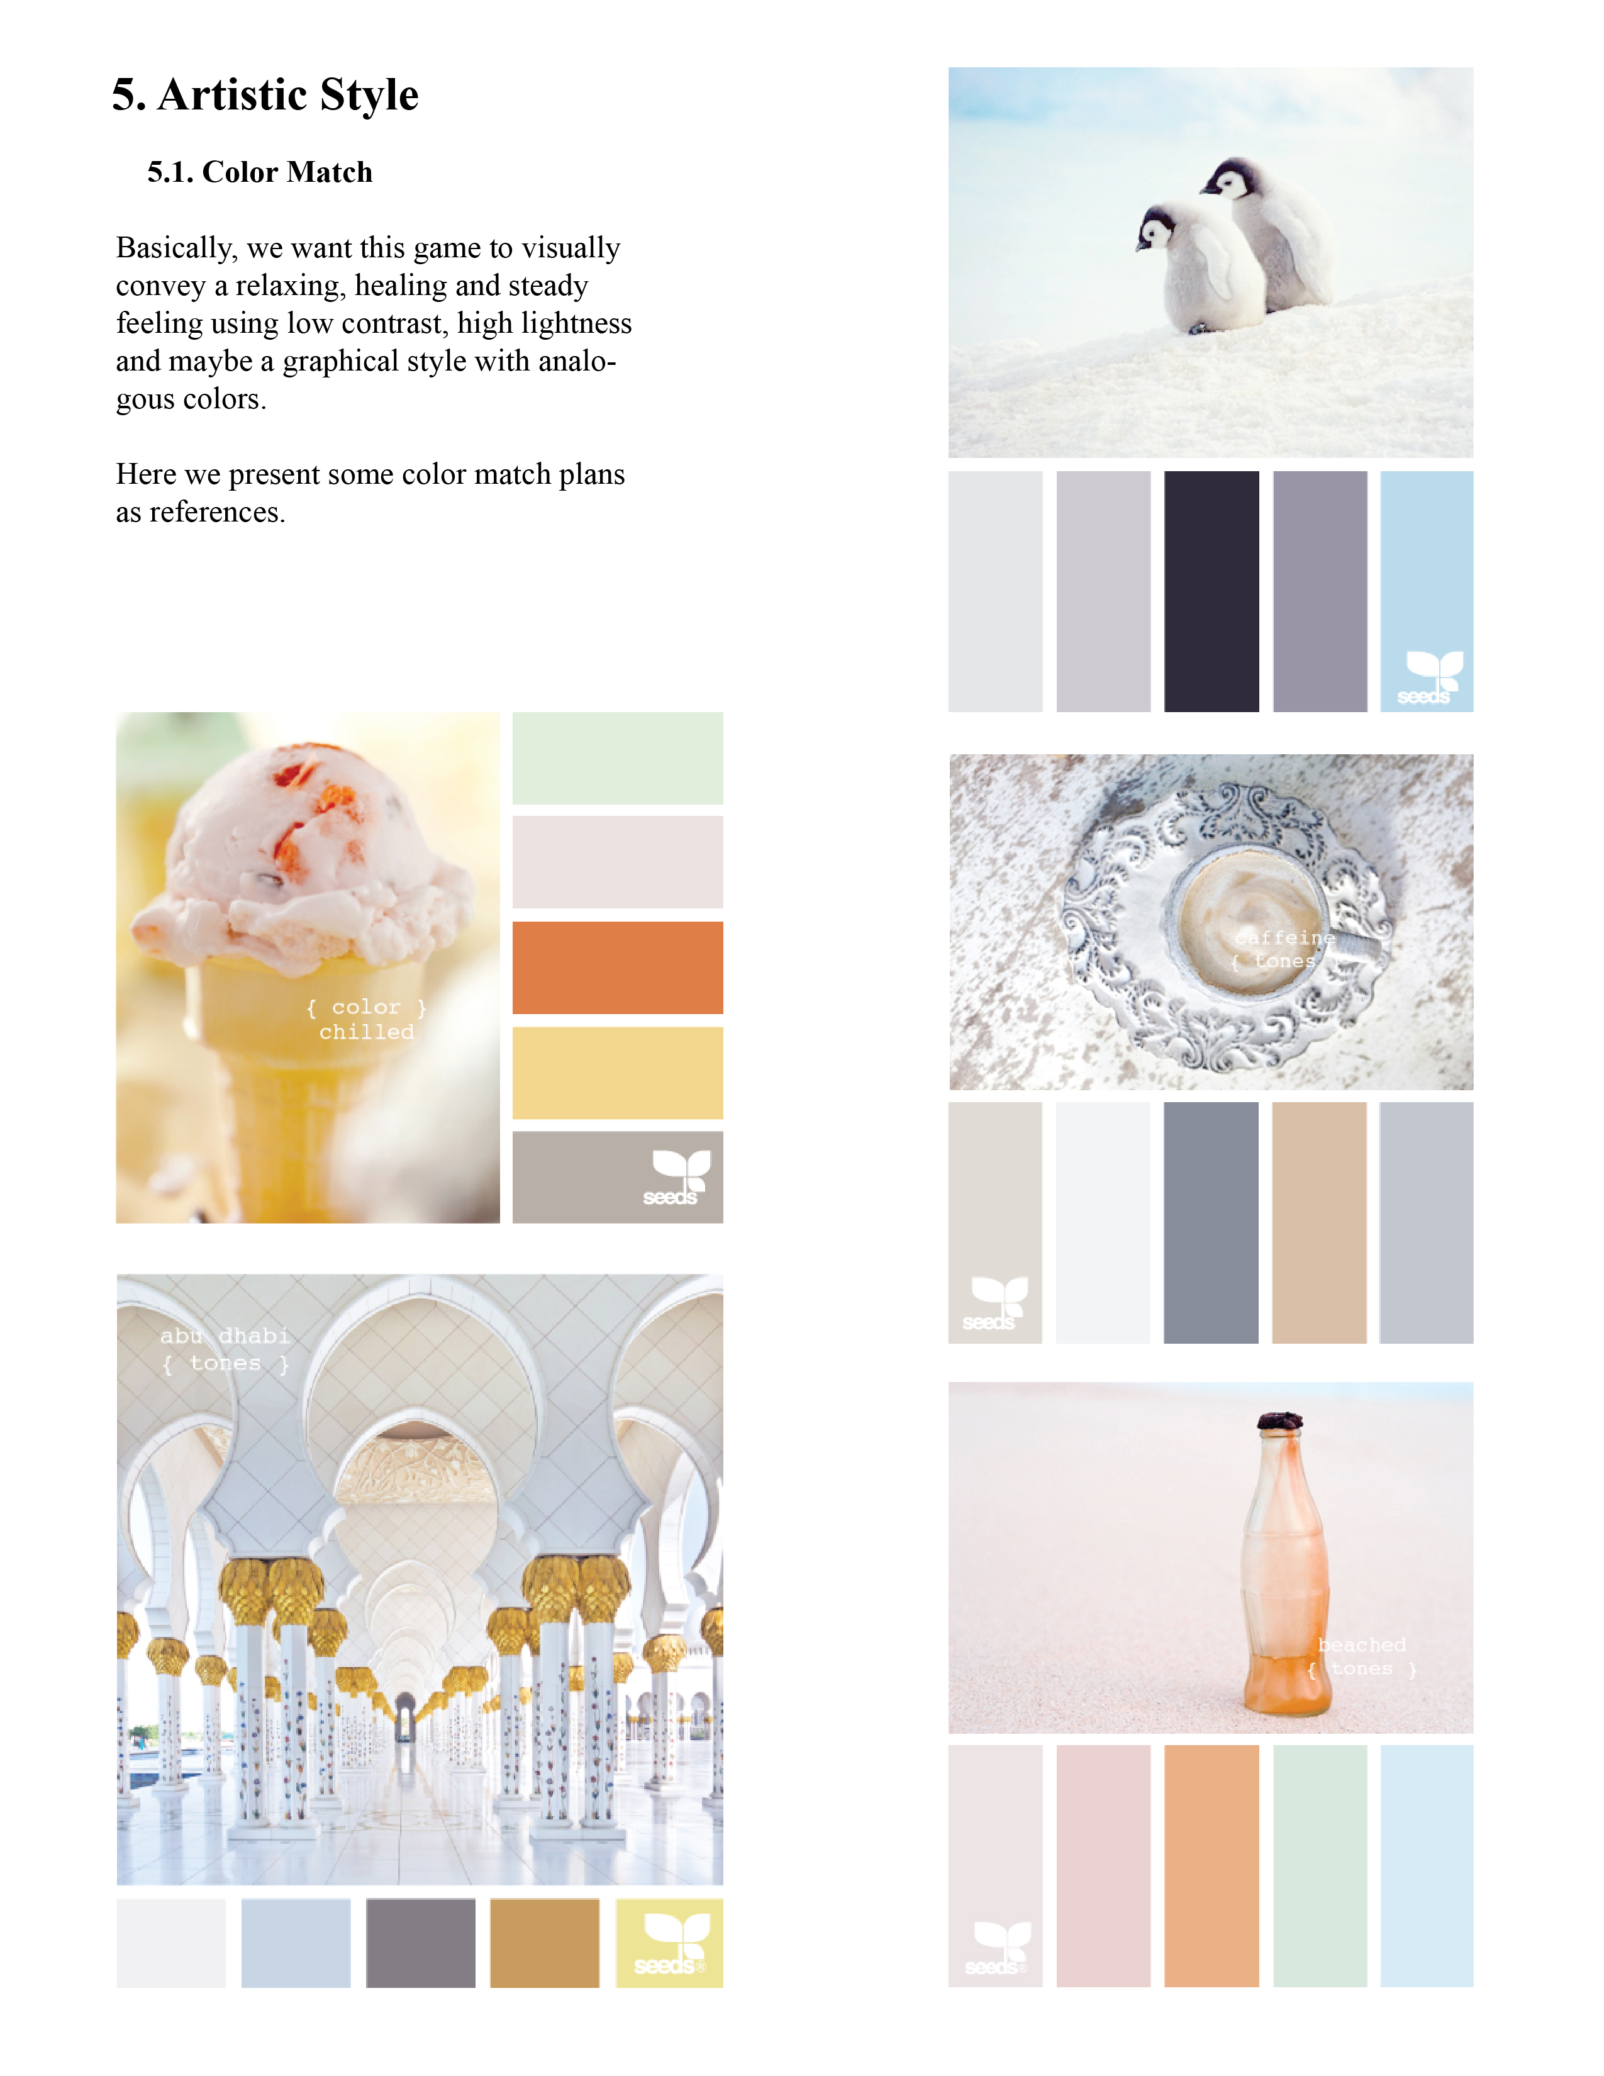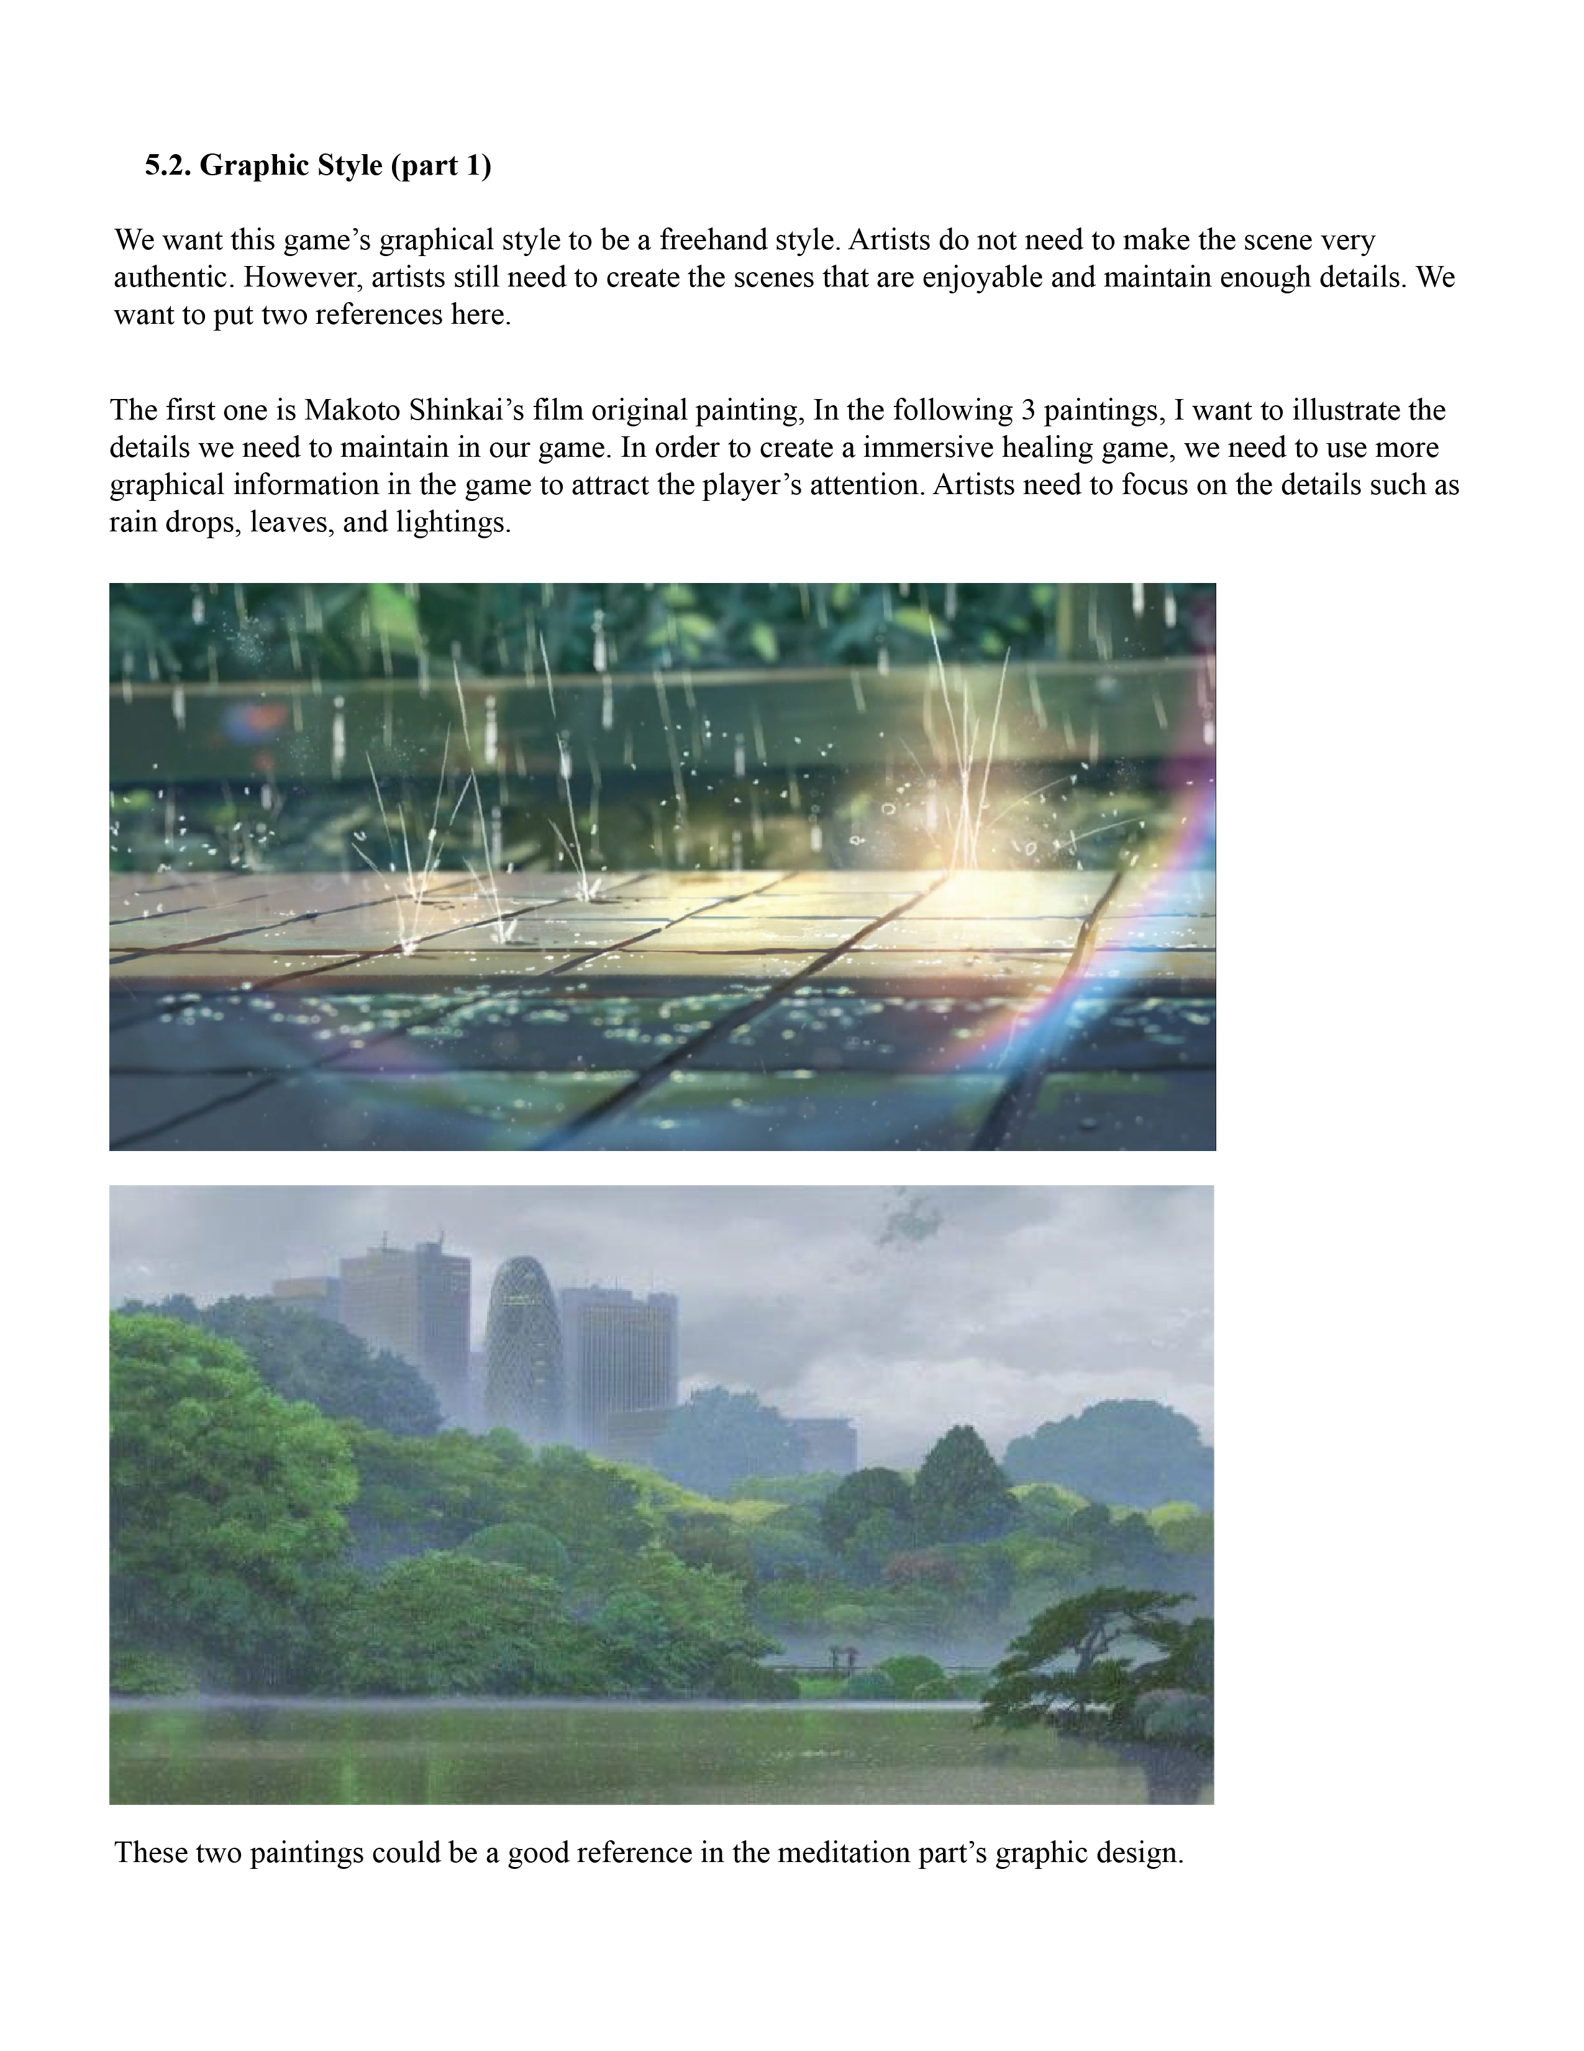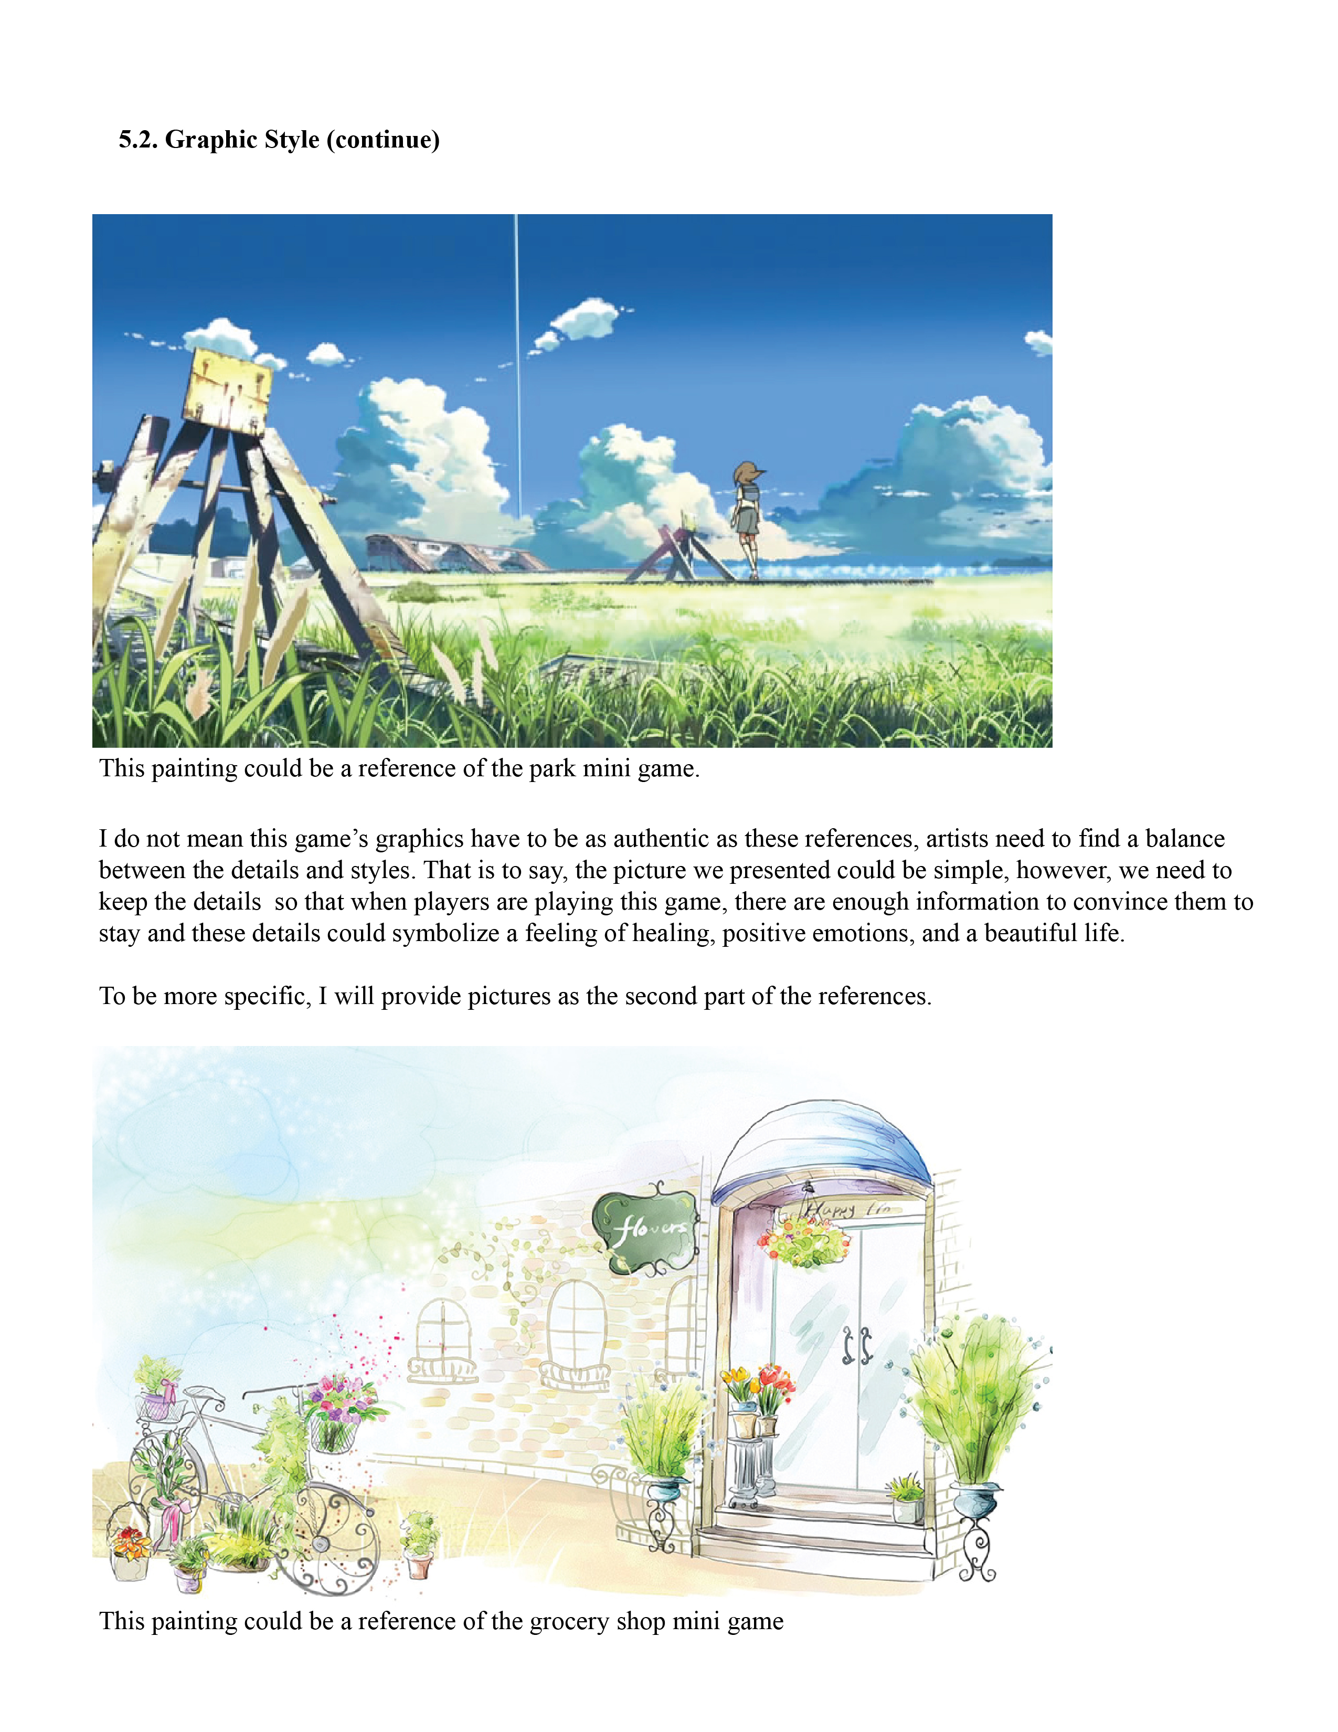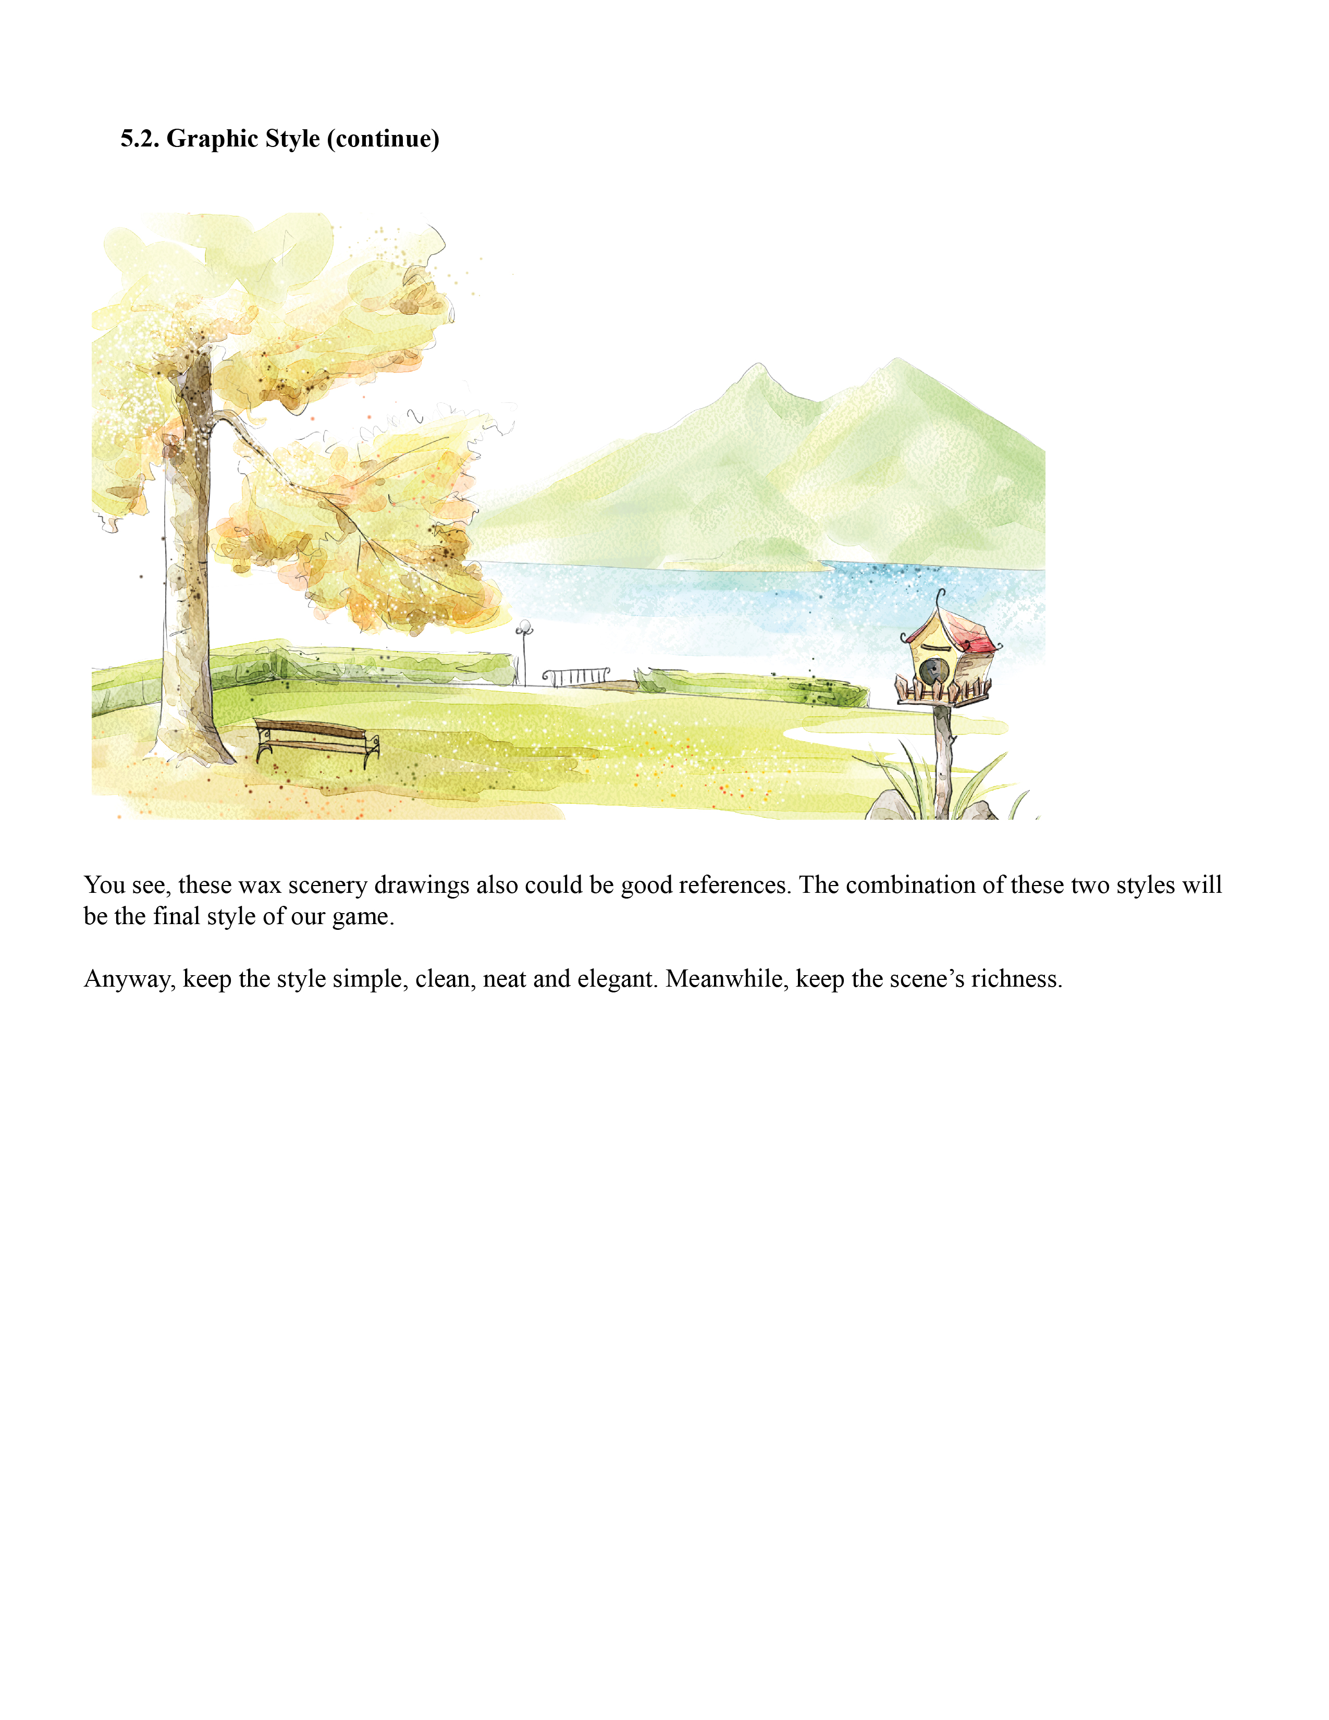

**6. Levels**

[Here is where all the mini games will be placed in the Game Design Document. All of them follow the same suggested template.]

**6.1. Bedroom**

**6.1.1. Introduction**

This is basically a dressing game. The player can dress herself up and put make-ups on and wear jewelry or accessories. We aim at helping the player reclaim her identity and affirm her choices. The game will neither teach her how to do things nor give any suggestion, she will be free to do whatever she wants.

The game will always give her some positive feedback besides some rewards that we will explain later. There is as well a side quest system that will awaken the player’s curiosity and her desire to play again. Once triggered, the quest will build connection between other mini games that will make the story more catching and immersive.

**6.1.2. Game Purpose**

The main purpose of this mini game is self-reclamation. The player here has the choice to be whatever she wants with few restrictions. We want her to identify herself to the avatar and make her own choices considering only her desires and her tastes.

**6.1.2.1. Experience**

The experience of the game is freedom “you can be whatever you want” and creativity since you can try different outfit and make new combinations.

**6.1.3. Characters**

**6.1.3.1. Main Character**

The main character here is the player’s avatar. She will be introduced earlier in the game when she will actually choose the shape and the face of her character. Here she can make other changes like dressing it up, changing hairstyle and or putting make up on.

**6.1.3.2. Companion**

The same companion that is introduced at the beginning of the game. He will usually give positive feedback about how the avatar looks.

**6.1.3.3. NPCs**

We don’t have any NPCs introduced in this mini-game.

**6.1.4. Core Mechanics**

This mini-game is a point & click dressing game. There are a few actions that the player can do:

* She can walk around the room by pointing and clicking a certain place.
* She can click on the dresser or the closet to open their respective interfaces.
* Once theses interfaces are displayed, the player can choose items to try on her avatar and she will see the changes instantly.
* In the corner we have the actual weather and the event we are dressing up to (party, working out…)
* The “finish” button will close the interface and get back to the room view
* The companion gives positive feedback (“you look so great in this dress!”, “this outfit fits you perfectly!”…)
* If the outfit fits the weather and the event (we will have different combinations available), the player gets a little reward like a new outfit.
* In the dresser, there are pictures and notes ticked to the mirror.
* Clicking on a picture opens a number of pictures to choose from and stock it to the mirror.
* Clicking on the note opens a text field where she can type any message she wants.

**6.1.4.1. Controls**

The controls for this game are the left button of the mouse and occasionally the keyboard to write notes.

* **On Mouse Click:** There are possibilities
* Clicking a space in the room moves the character to that place.
* Clicking an arrow an object (dresser, closet) opens the appropriate interface.
* Inside the dresser’s interface, clicking on the hair brush, jewelry box, nail polish and make-up will open the respective hairstyles, different jewelry and colors for nails and makeup.
* Inside the closet’s interface clicking tags (like “hats”, “shirt”, “boots”) to choose categories of clothing.
* Clicking on an item will display the changes directly on the avatar.
* **On Mouse Hover:** when the mouse hovers on the arrows or objects themselves, notes like “click here and begin to choose your dresses” will appear.

**6.1.4.2. Storyline**

In the very beginning, the player will start this game in her room where there are furniture and decorations.

**6.1.4.3. Storyboards**

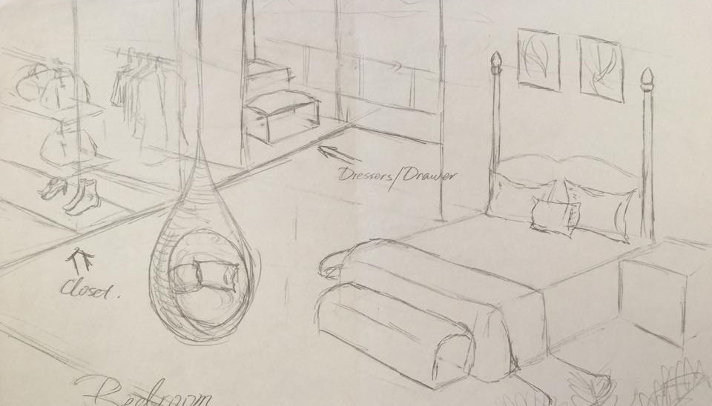

Figure 6.2 Bedroom sketch

* At first, we have the bedroom view where the player can walk around and click on objects like the closet or the dresser.

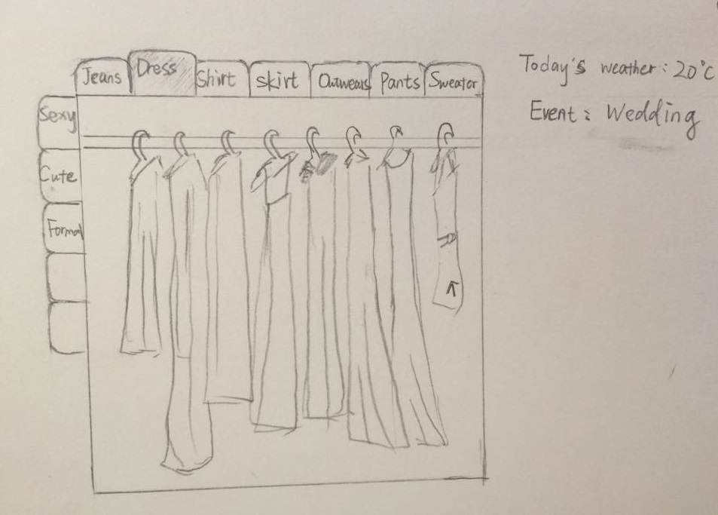

Figure 6.2. Closet Interface

* Then, when she clicks on the closet she gets the closet interface, where she has the different tags to choose from. She also has the weather and the event she’s attending.

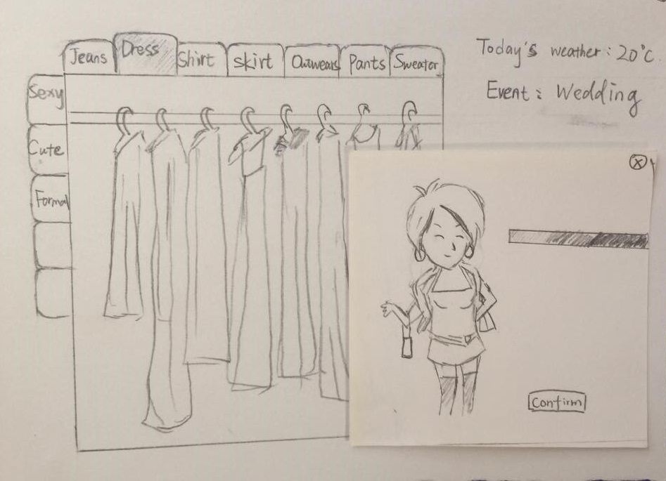

Figure 6.2. Avatar clothes

* When she chooses one outfit, she will see how it would look on her avatar. Then she can click “finish” and get back to the main room interface. She can choose to come back or open the dresser.

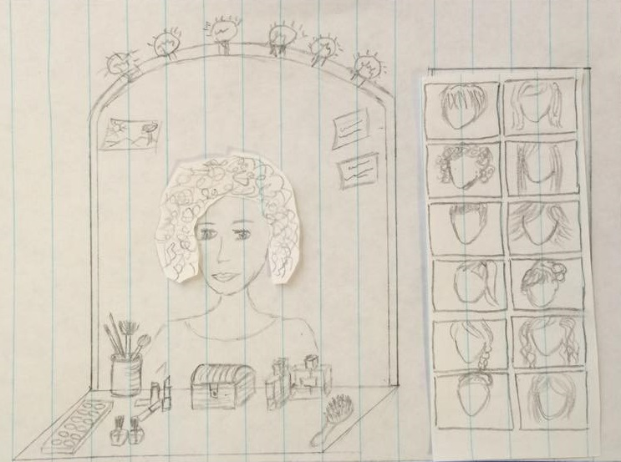

Figure 6.2. Dresser interface: hairstyles

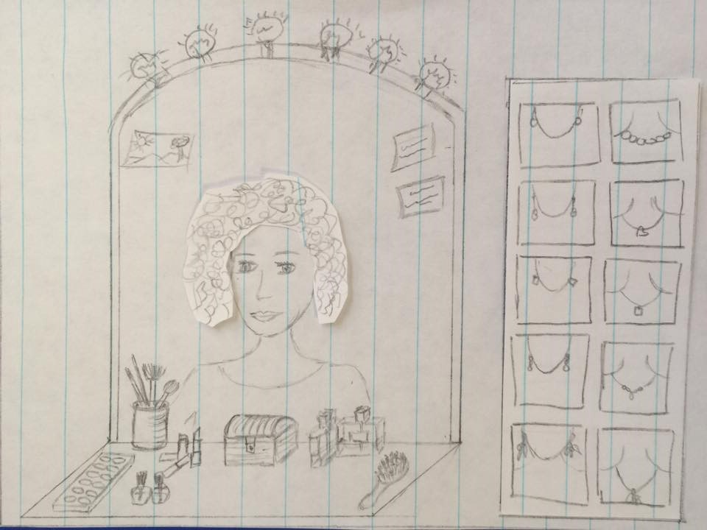

Figure 6.2. Dresser interface: Jewelry

* When she opens the closet interface she can click on the brush to open the hairstyles, or select the jewelry box to choose which ones to wear. She can also select make up and nail polish…
* After she finishes she can leave this interface and then leave the room.

**6.1.4.4. Side Quests**

To make the game more catching we decided to add side quests. Sometimes, after dressing up, the player can find a torn piece of paper. The piece contains a part from a message. When she collects all the pieces, she can read the hidden message. It can be an invitation to a special event to attend or a new place to go. The player can choose to accept or refuse the unlocked event.

The pieces of the message can also be found in other mini games.

**6.1.4.5. Win Condition**

In this game we don’t have a win condition. It’s all about the player’s taste and personal choices. There are few rewards in case of good choices but it doesn’t really count as a win.

**6.1.4.6. Lose Condition**

There is also no lose condition. We can’t judge someone on his clothing tastes.

**6.1.4.7. Reward Mechanics**

The reward mechanics consist of pieces of clothing, jewelry, new hairstyles… that the player can unlock when she dresses well.

**6.1.5. Artistic Representation**

The artistic style of the bedroom should be unified with the whole game’s style which is simple and clean.

A reference of the bedroom design:

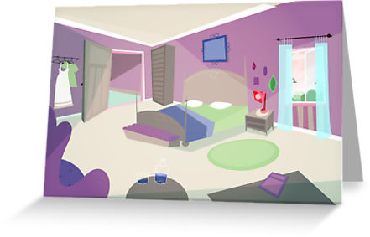

Please refer to the drafts shown in the Storyboards (Section 6.X.4.3) for artistic representation of the Bedroom’s mini games as well.

**6.1.5. Levels**

We don’t really have levels in this mini game. The only thing that changes from one session to another is the event and weather.

**6.1.7. Phased Development**

**6.1.7.1. Phase 1 (Basic Functionality)**

|  |  |  |
| --- | --- | --- |
| Feature | Description | Priority |
| The Dresser | -Change hairstyle  -Put Make up  -Wear Jewelry/accessories  -Put nail polish | High  High  Medium  Low |
| The closet | -Try clothes instantly  -Have different tags to organize clothes | High  High |

**6.1.7.2. Phase 2 (Side Quests)**

|  |  |  |
| --- | --- | --- |
| Feature | Description | Priority |
| Random pieces of paper. | -After dressing up, the player will find pieces of torn paper to reconstruct and reveal a message. | Medium |
| Connection to other mini games | -Some pieces could be found in other mini games | Low |

**6.1.7.3. Phase 3 (Reward system)**

|  |  |  |
| --- | --- | --- |
| Feature | Description | Priority |
| A new item as reward | -If the clothes matches the event and weather, the player wins a new clothing, jewel or accessory… | Medium |

**6.2. Living Room**

**6.2.1. Introduction**

The living room decorating mini game is the second game in the sequence. After the player has chosen her avatar, she will be directed to move to the living room. Once there, the player will be encouraged to select one of three preset furniture arrangements. This layout will be permanent for the remainder of the game.

Once the layout is confirmed, the companion will then encourage the player to redecorate the room. Individual pieces of furniture can be changed out for similar pieces with an in-game menu, or can be completely removed from the room using the same menu. The furniture can be further personalized with predetermined colors and pattern swatches. Similar color and pattern changes can also be applied to the room’s features and to ornamental items such as lamps and window dressings.

The player will receive praise (via dialogue) from the companion once she decides that her room design is complete. After the first play-through, a continuation of the story including NPC dialogue will prompt the player to move to the next game. In all other circumstances, the player can choose to return to the living room and play the mini game again at any time.

**6.2.2. Game Purpose**

The purpose of the room redecorating mini game is to introduce the player to the apartment space and allow them to personalize that space. The personalization aspect of this game is intended to make the player feel “at home” with the game. It also helps the player to decide what their personal style is by confronting them with a preselected design and allowing them to change it.

**6.2.2.1. Experience**

Core experience: The player should feel relaxed and should feel comfortable being creative with the space provided.

The redecorating mini-game has win/lose conditions and no time limit, so the player has free rein to do what she wants with the space. The companion makes no negative judgments about the player’s choices, and makes positive comments when the player is finished with her design, so creativity itself is rewarded. The mini game can be replayed at any time, and this lack of permanence can allow the player to explore different styles without feeling that the setup is permanent or that the style will define their interactions with the whole game.

The set furniture style provided with each seating arrangement allows the player to preview the layout that she wants, but also see immediately what style she does or does not want. It will be easier for the player to decide what she does not like, so this will prompt her to think about what would fit better in the space and explore the menu to decide what to replace the disliked item or items with. This setup should encourage the player to be creative and to figure out what her personal style is.

**6.2.3. Characters**

**6.2.3.1. Main Character**

**Name**: Player’s name

**Description**: Chosen by player. Subject to the art and animation style of the main game.

**Introduction**: The player’s avatar is introduced standing in an area of the living room (that is not used for redecorating) as soon as the player enters the mini game.

Player perception: The player will perceive their avatar as standing as an avatar while they redecorate. The avatar may optionally move with occasional animations or respond to player actions in the mini game.

**Intention**: Adding the avatar to the game space is intended to give the player a feeling of immersion. The player should feel that the living room is specifically her space to personalize as she pleases, not just a blank space that she cannot act upon.

**6.2.3.2. Companion**

The companion will be in the upper left corner of the screen, above the player’s avatar and out of the way for the redecorating. The companion will introduce the concept of the game, walk the player through the steps to redecorate, and will wrap up at the end and introduce the NPC story.

**6.2.3.3. NPCs**

* **NPC #1 – First neighbor (not shown)**
* **NPC #2 – Second neighbor (not shown)**

Please see the storyline for discussion of the NPCs’ contribution to the mini game.

**6.2.4. Core Mechanics**

This game is a point and click game, meant to provide a structured “sandbox” environment for the player. The emphasis is on choice and it is provided in a variety of ways: In the overall room arrangement, the room’s contents, color, and patterns. The initial impression given to the player is one of choices and potential. This feeling is driven by the companion’s prompts and is accompanied by positive feedback from NPC dialogue after the first play-through.

**6.2.4.1. Controls**

All of the controls for this game will be completed using the left mouse button.

* Arrangement Selection
  + Select arrangement with mouse button
  + Press “confirm” menu button to proceed
* Select object by clicking with mouse button
  + Editing menu will open
* Editing menu
  + select object in menu to replace or edit object currently in room
  + menu tabs
    - items
    - color swatches
    - pattern swatches
  + click or drag scroll bar to see selections in a category

**6.2.4.2. Storyline**

On the first play-through, the game will transition from the bedroom level by suggestion from the companion, but only if the player chooses to move forward. The player will navigate to the living room. Once there, the companion will announce that the current setup is new and temporary and will suggest to the player to choose a new furniture arrangement. The companion will then use dialogue prompts to encourage the player to redecorate the room.

Upon finishing, the companion will praise the player’s design choices. The NPCs will then be introduced. A short dialogue section with the NPCs or commentary by the companion will introduce the next stage of the game.

* The NPC dialogue will introduce the kitchen game.
* Commentary or prompts from the companion will allow the player to select any of a number of choices, including mini games already played and new games other than the kitchen game.

**6.2.4.3. Storyboards**

Please note that representations of the companion and avatar were omitted from the storyboards for clarity.

* Opening transition: bedroom to living room.

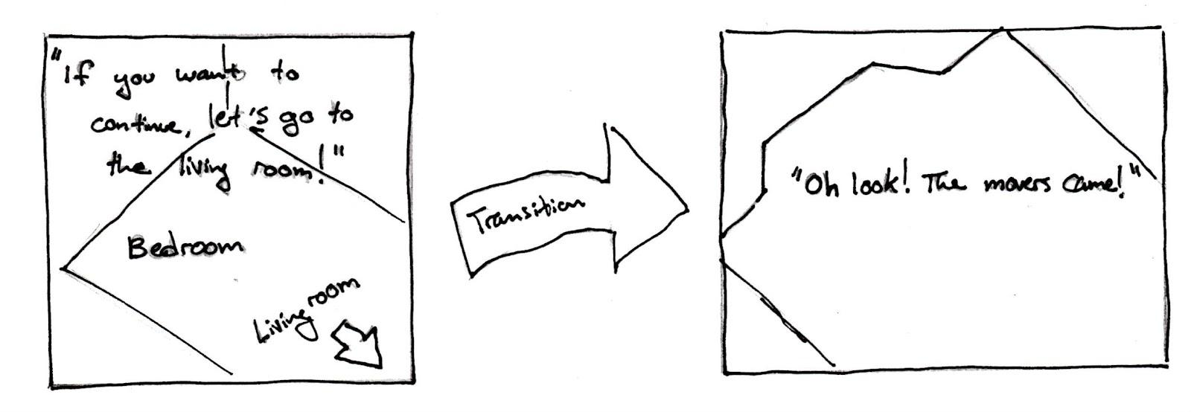

* Furniture arrangement selection screen.

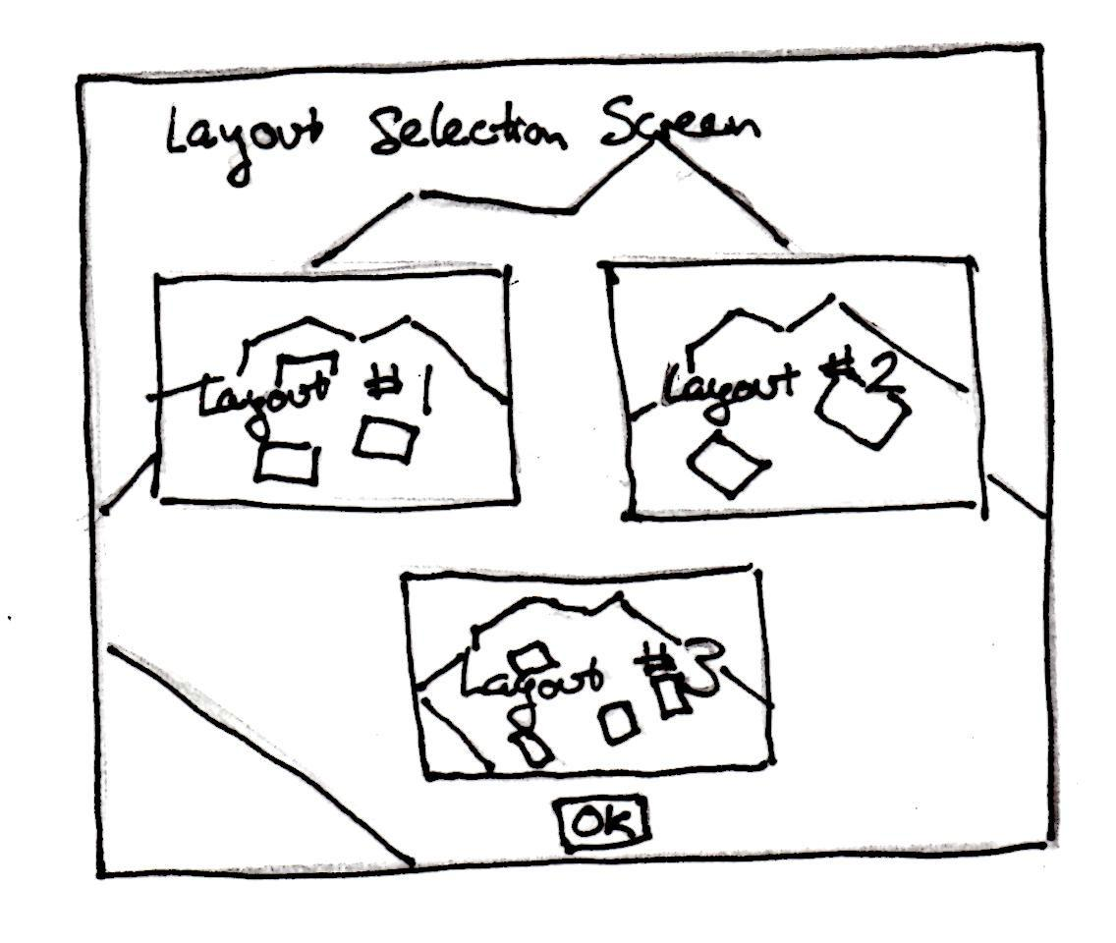

* Redecorating prompts from companion.

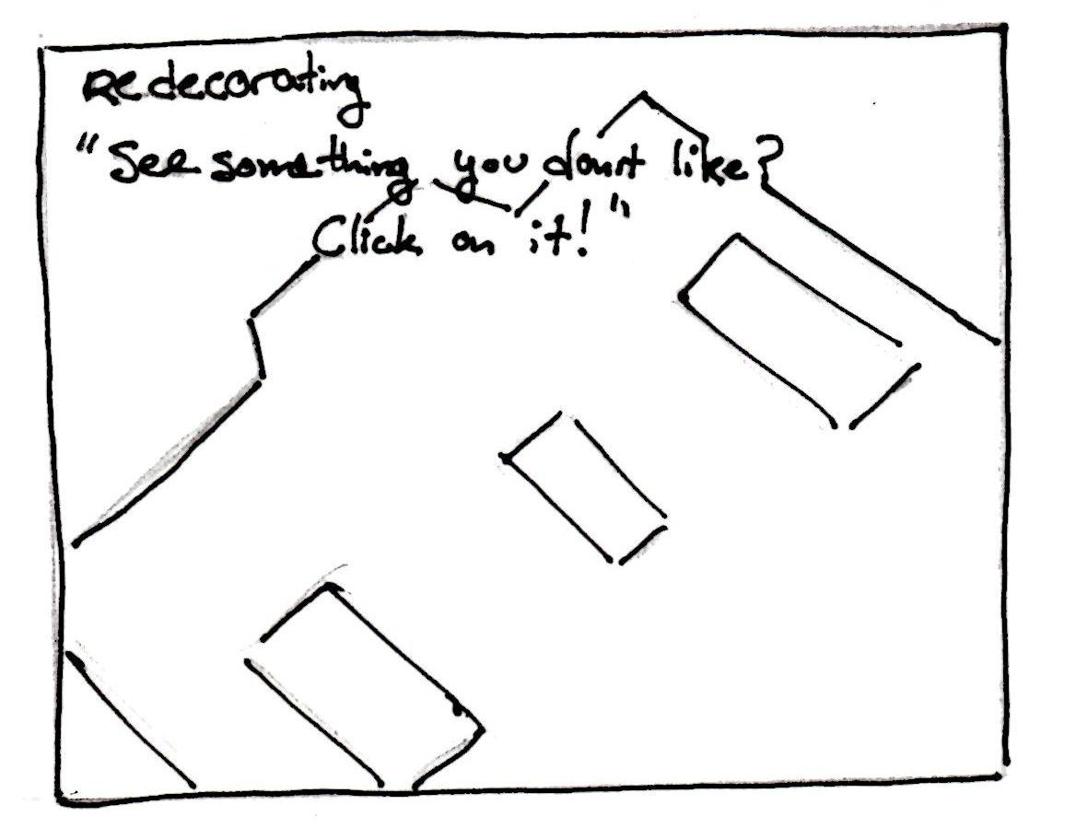

* Ending companion commentary and dialogue reward.

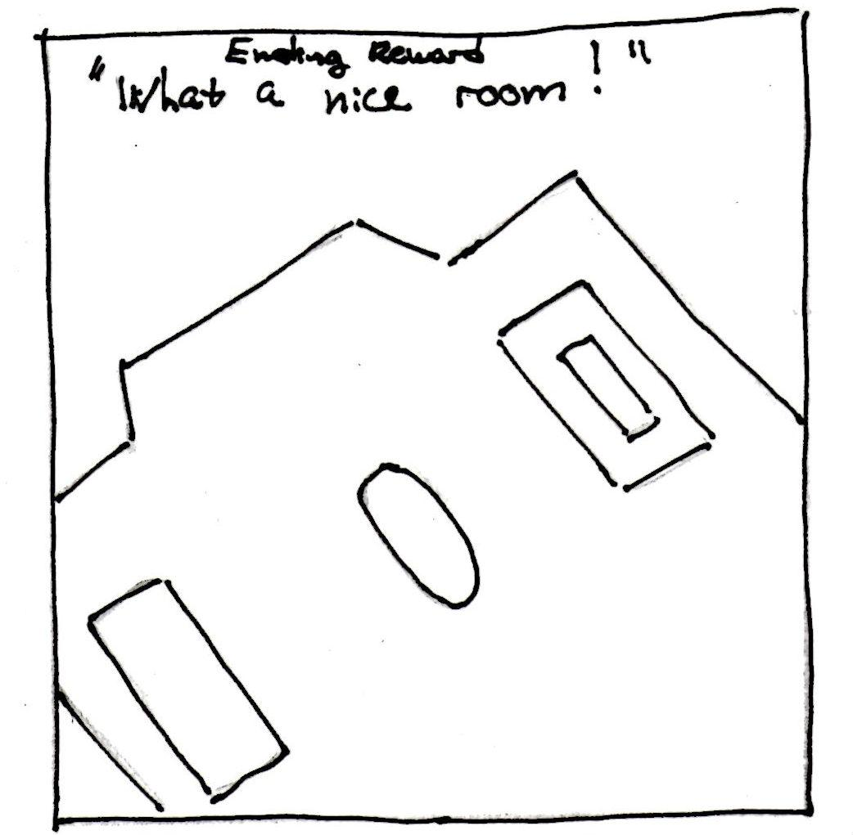

* Ending transition and introduction of NPCs.

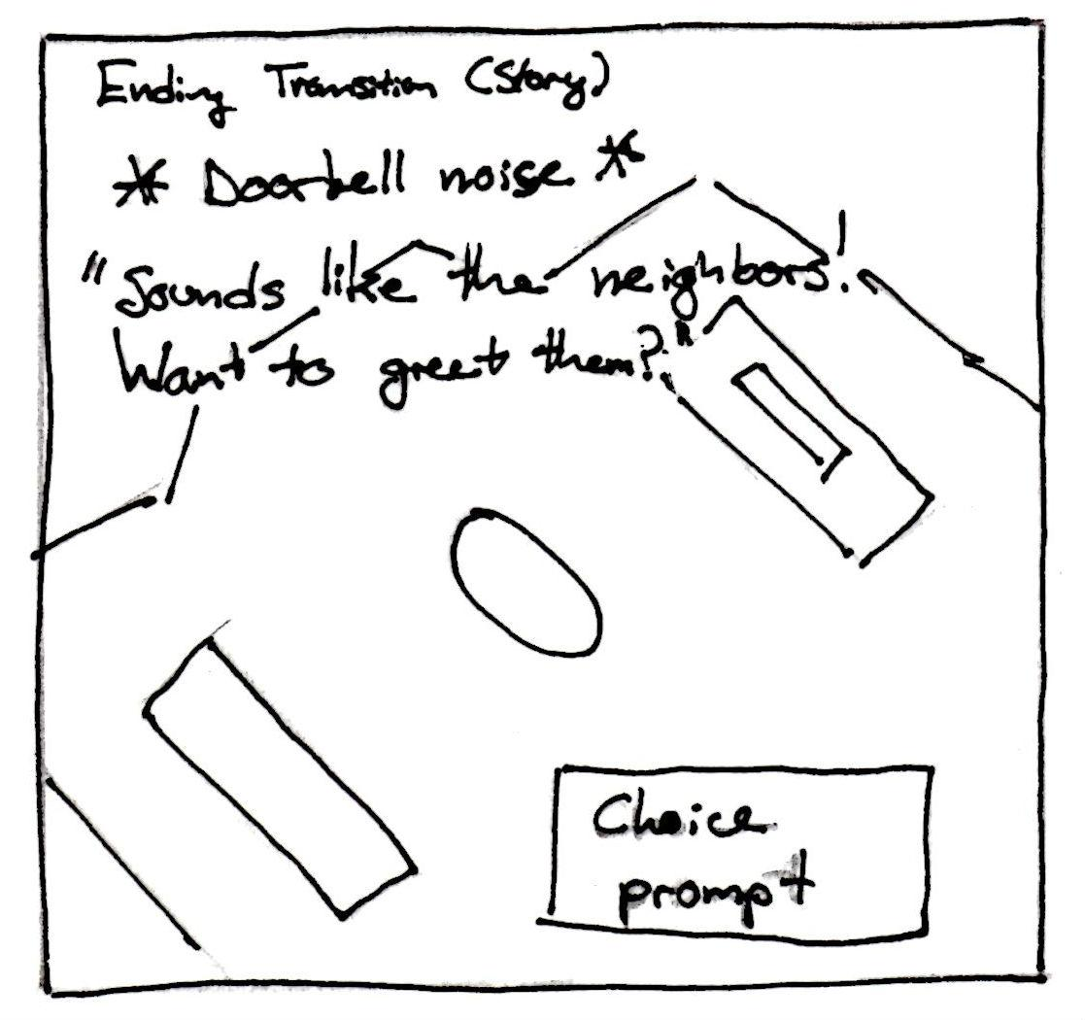

**6.2.4.4. Side Quests**

The base version of the mini-game does not contain any side quests. See “Additional Ideas and Possibilities” for future ideas for side quests.

**6.2.4.5. Win Condition**

This game has no win condition. As a redecorating and personalization game, there is no state in which some the player’s choices can be more ideal than others.

**6.2.4.6. Lose Condition**

This game also has no lose condition. As a personalization game, there is no state in which the player’s choices will be considered unacceptable for progression.

**6.2.4.7. Reward Mechanics**

The companion will respond favorably when the player is finished decorating. These responses may be dialogue (including compliments or design-specific comments) or visual changes in the companion, if applicable.

Additionally, after the first time the mini game is played, neighbor NPCs will arrive and compliment the player on their living room.

**6.2.5. Artistic Representation**

Please note that the companion and player avatar were omitted from the sketches for clarity.

An example of the basic arrangement for the “breakfast nook” (Level 1) design:

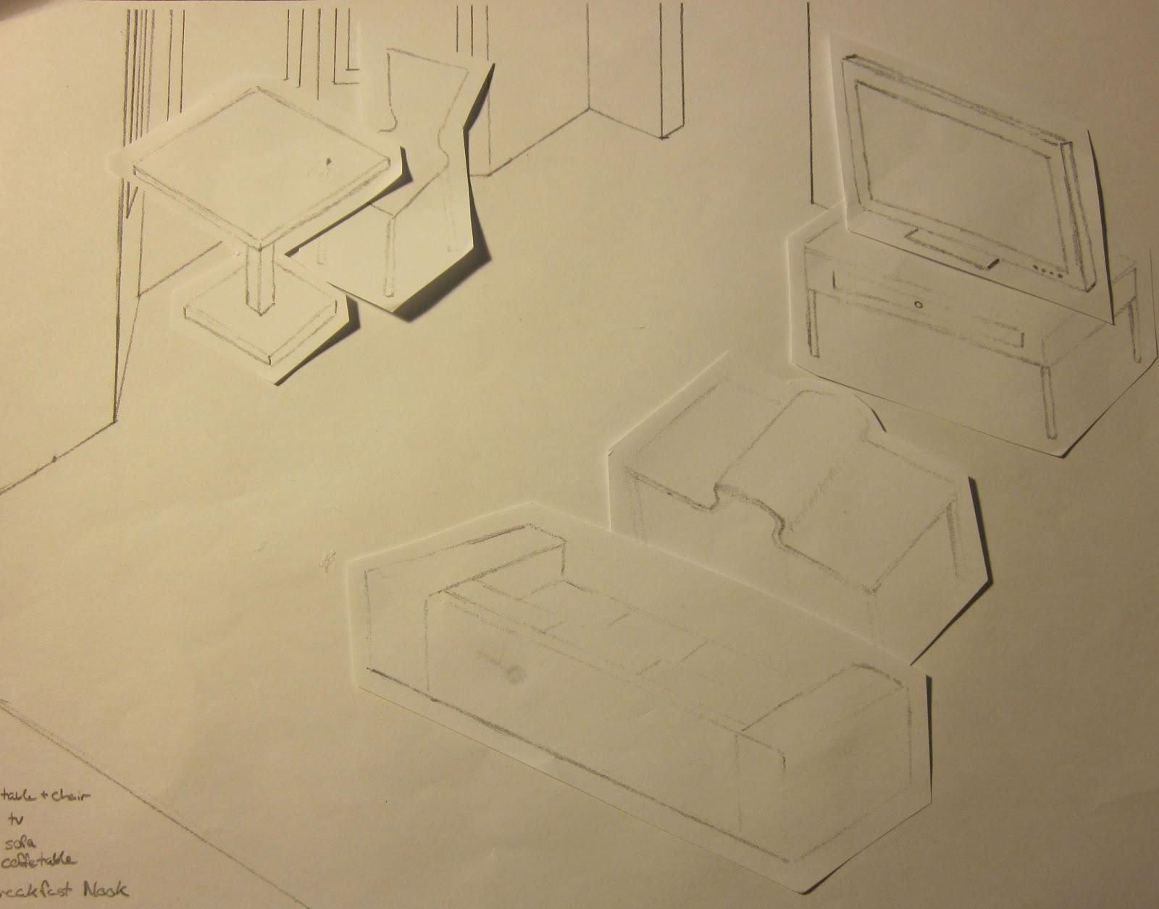

An example of room when an object has been clicked on and the menu has been opened:

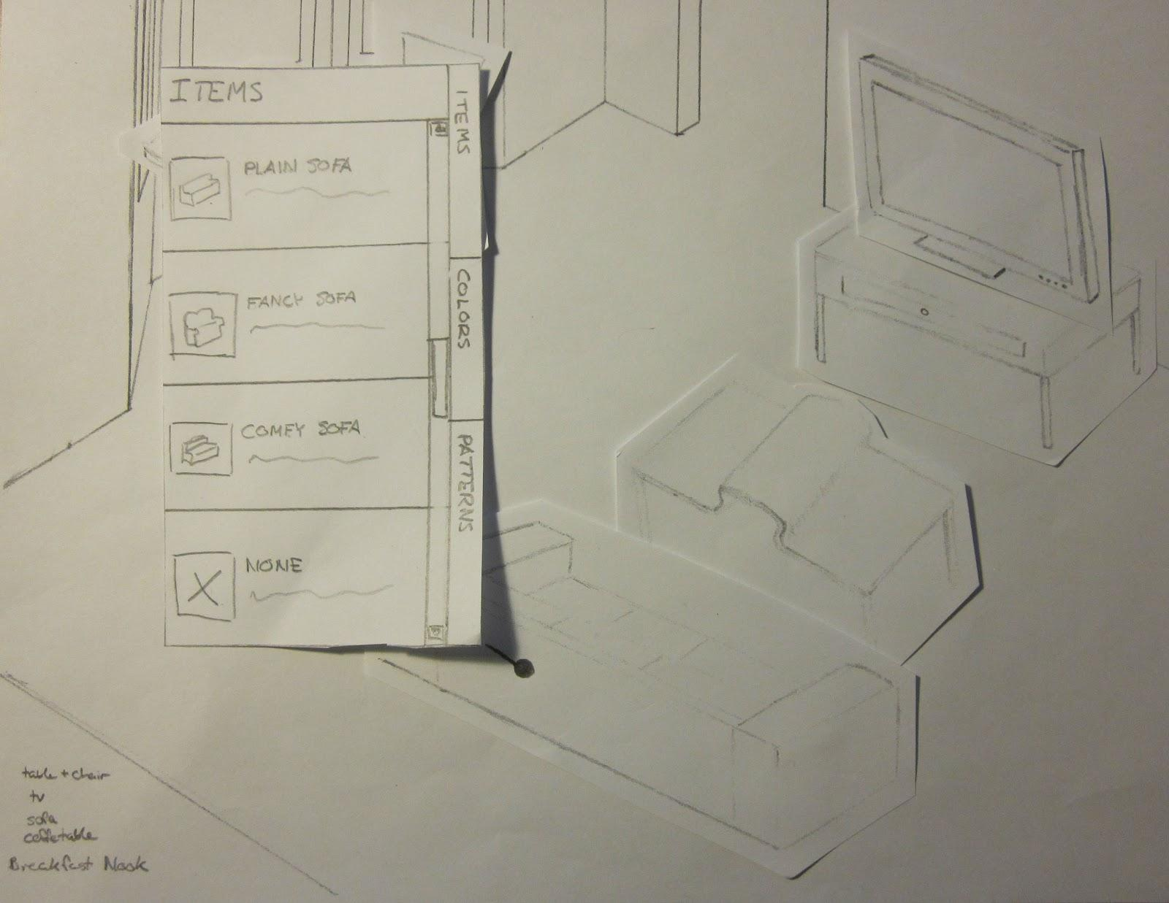

An example of the same room, this time with the sofa replaced with a different design:

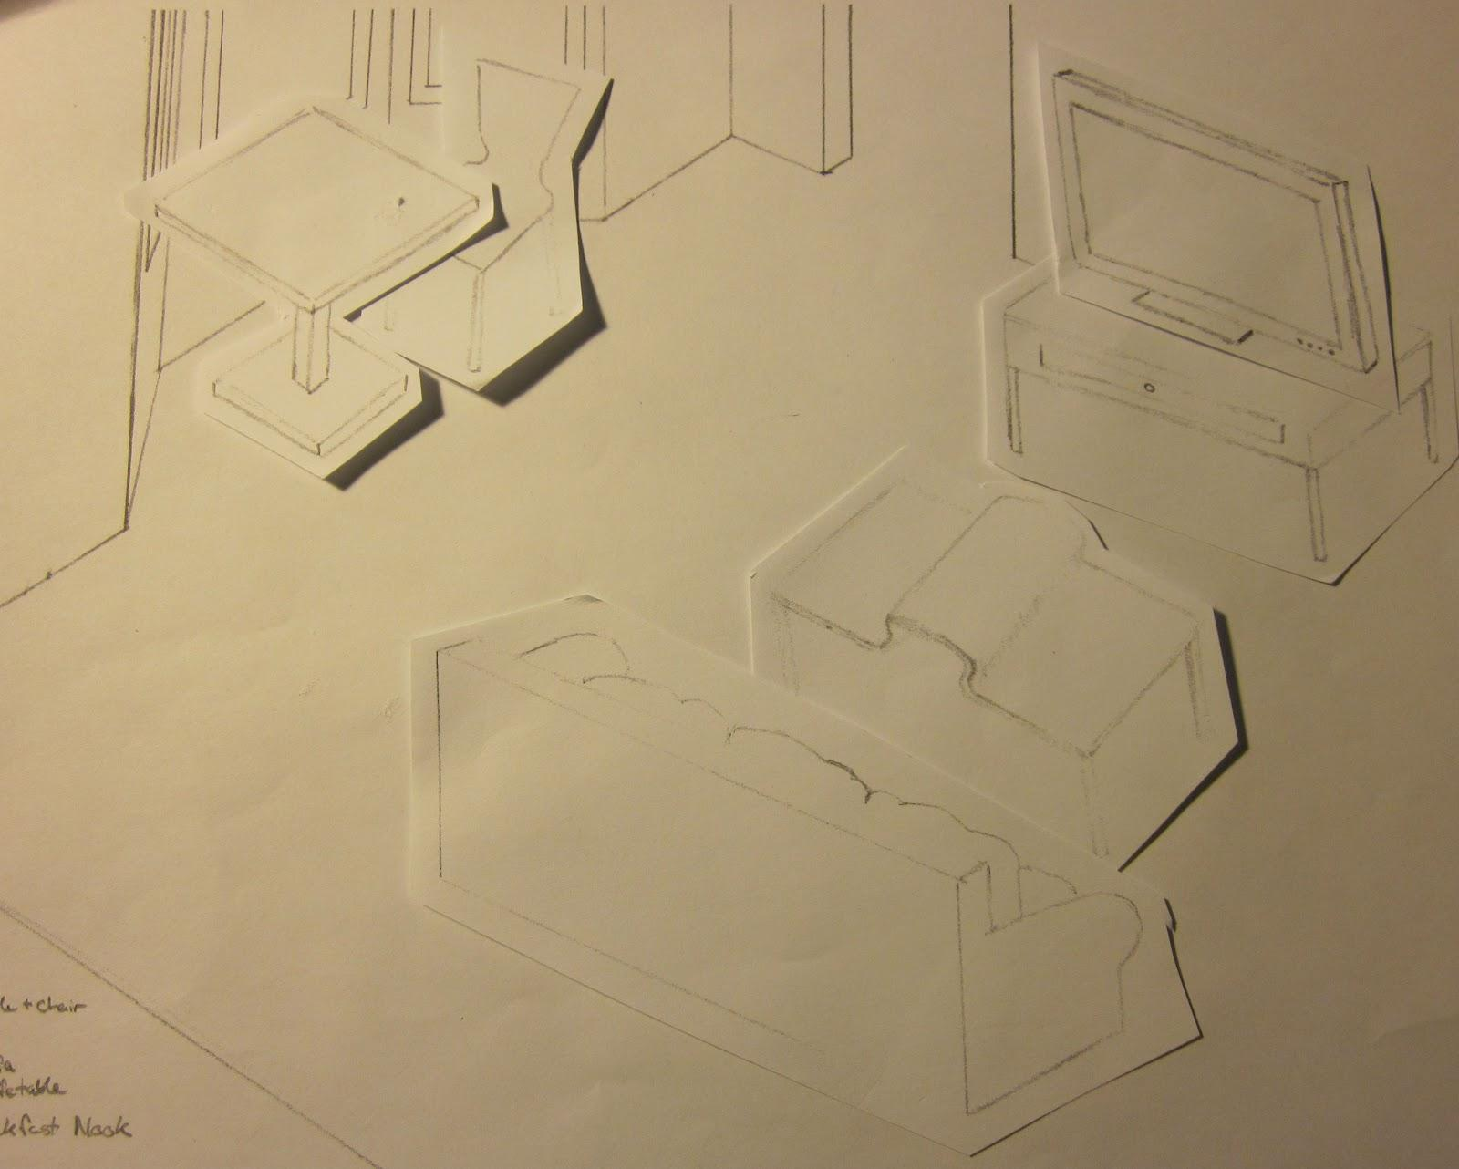

**6.2.5. Levels**

Different seating arrangements will be defined as different levels or game modes. There is no change in difficulty between these levels.

**6.2.5.1. Level 1**

The “breakfast nook” arrangement will have a modern design.

|  |  |
| --- | --- |
| Location | Item |
| Bay Window | Table and chairs |
| Right wall | TV and stand |
| Center | Coffee table |
| Left wall | Sofa |

**6.2.5.2. Level 2**

The “reading nook” arrangement will have a casual design.

|  |  |
| --- | --- |
| Location | Item |
| Bay Window | Side table and armchair |
| Right wall | Bookcase |
| Center | TV and stand |
| Left wall | Sofa |

**6.2.5.3. Level 3**

The “conversation area” arrangement will have a formal design.

|  |  |
| --- | --- |
| Location | Item |
| Bay Window | Armchair |
| Right wall | Bookcase and armchairs |
| Center | Coffee table |
| Left wall | Sofa |

**6.2.7. Phased Development**

**6.2.7.1. Phase 1 (Base functionality)**

|  |  |  |
| --- | --- | --- |
| Feature | Description | Priority |
| Base room arrangement | A simple room design with preset furniture placements | High |
| Furniture selection | Player should be able to choose between a small selections of furniture. | High |
| Furniture removal | Player should be able to choose to remove any item from the room. | High |

**6.2.7.2. Phase 2 (Expanded functionality)**

|  |  |  |
| --- | --- | --- |
| Feature | Description | Priority |
| Additional room arrangements | Two additional furniture arrangements should be added. The player should be able to choose an arrangement the first time they play the game. | High |
| Additional furniture selections | Furniture selection should be expanded to include specialized furniture for new arrangements. | High |
| Furniture personalization | Predetermined colors and pattern swatches should be available for the player to apply to any furniture item. | Medium |

**6.2.7.3. Phase 3 (Decorative touches)**

|  |  |  |
| --- | --- | --- |
| Feature | Description | Priority |
| Room personalization | The player should be able to select features of the room (floor, walls, ceiling, etc.) and customize them with predetermined colors and pattern swatches. | Medium |
| Decorative items | The player should be able to select ornamental items (such as lamps, window coverings, etc.) to place in the room. | Low |
| Decorative items personalization | The player should be able to apply predetermined colors and pattern swatches to ornamental items. | Low |

**6.2.8. Additional Ideas and Possibilities**

Small “game show”-style mini games may be added to provide rewards to the player. The player can win these games to unlock new furniture items.

**6.3. Kitchen**

**6.3.1. Introduction**

The Kitchen mini game is presented after bedroom and living room. This game has two screens. On the first screen you can look through the recipe book and choose what you want to cook. The second screen represents cooking.

After cooking, Sparky usually suggests the player to buy some new products. This is how transition to the grocery game is done. If the player doesn’t have enough resources for cooking, he needs to do the groceries.

After successful cook, players will be rewarded by Sparky with a complement.

**6.3.2. Game Purpose**

The purpose of the kitchen mini game is to make the player to return back to the game and to have fun. Most of the game audience likes to cook and game mechanics are aimed to target this audience.

This game is also is a transition between other mini games and is a time killer. With kitchen mini game the main character can cook for her pet of for neighbors if she decides to invite them.

**6.3.2.1. Experience**

Core experience: simplicity and fun. This game also introduces some strategy.

The kitchen game gives the player a feeling of improvement. The more you play – the better results you show. To make this experience more clear, your own leaderboard is a part of this game, so every time you beat your last score in cooking the same dish – Sparky compliments you and encourages playing more.

**6.3.3. Characters**

**6.3.3.1. Main Character**

**Name**: Player’s name

**Description**: Chosen by player. Subject to the art and animation style of the main game.

**Introduction**: Main character can only show up in dialogs with Sparky.

**Intention**: Main character represents the player, so generally the player controls the main character. In this mini game it is now shown visually.

**6.3.3.2. Companion**

Sparky plays very important role in first level – tutorial level. Companion teaches the player how to browse the recipe book and how to control the cooking process.

What is more, Sparky almost always rewards the player for completing a level, beating her previous best score, etc.

During the gameplay Sparky will not be visualized.

**6.3.4. Core Mechanics**

Core mechanics of the kitchen game is match three. The player can swap adjacent objects to get three of a kind in a row or a column. Three patterns for match-3 objects are shown in figure 1. If there are no possible moves, a big hand grabs all the objects and mixes them randomly.



**Figure 6.3.4.a. Three potential match-3 patters**

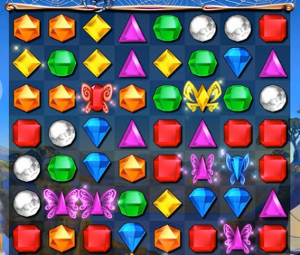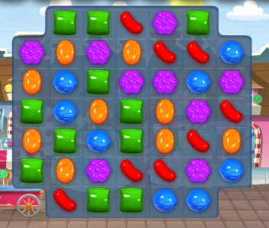

**Figure 6.3.4.b. *Bejeweled* screenshot on the left and *Candy Crush Saga* screenshot on the right.**

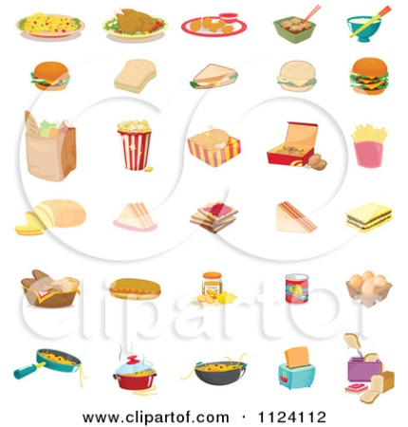

**Figure 6.3.4.c. Grocery products.**

Special mixes are available in this game. When the player matches four (or more) of a kind in a row or a column, L-shape or T-shape, a special object is spawned. This mechanic is introduced in *Bejeweled* game (figure 2). With this action the player earns achievements. Also achievements are earned when the player mixes two special objects. This mechanic is demonstrated in C*andy Crush Saga* game (figure 2).

The goal of the kitchen game is to collect achievements needed for a dish. All the objects in this game are products from grocery store (figure 3). So for example to cook fried eggs the player need to get at least one match-4 eggs and at least one match-3 frying pans.

**6.3.4.1. Controls**

To navigate through the recipe book the player has to press a button with an arrow. To swap two objects the player must click on a selected one and start dragging it in one out of four directions.

All of the controls for this game will be completed using the left mouse button.

**6.3.4.3. Storyboards**

All the graphics in this game must be in the same style as other mini games. Recipe book sketch is shown on figure 4. Each page of this book have name of dish, picture, description, category, difficulty level and achievements needed to cook it.

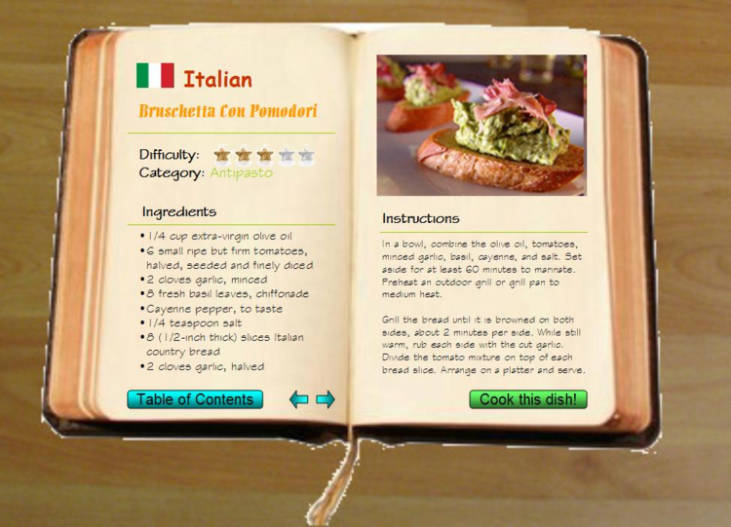

**Figure 6.3.4.3.a. Recipe book.**

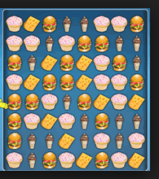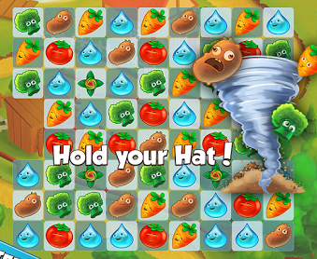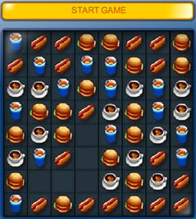

**Figure 6.3.4.3.b. Screenshots of match-3 games.**

Examples for the second screenshot of the game are provided in Figure 6.3.4.b and Figure 6.3.4.3.b.

**6.3.4.5. Win Condition**

To win this game, the player needs to earn all necessary achievements for a level.

**6.3.4.6. Lose Condition**

Player cannot lose this mini game.

**6.3.4.7. Reward Mechanics**

When the player earns an achievement or passes the level, Sparky compliments her. When the player beats her own record on the same level she is also rewarded by Sparky.

Neighbors will say that the player cooks very well according to the main storyline.

**6.3.5. Artistic Representation**

Artistic representation for this game is done in the same style as main game and all the other mini games. Also it looks like the pictures on figures 2, 3, 4, 5.

**6.3.5. Levels**

As the player passes levels, she unlocks new dishes and new levels. Different amounts of object kinds are introduced in levels.

Levels of difficulty are affected by number and complexity of achievements needed for the dish.

**6.3.7. Phased Development**

**6.3.7.1. Phase 1 (Base functionality)**

|  |  |  |
| --- | --- | --- |
| Feature | Description | Priority |
| Recipe book | Interactive book with possibilities to choose different dishes. | High |
| Cooking | Match three game.  Achievements. | High |

**6.3.7.2. Phase 2**

|  |  |  |
| --- | --- | --- |
| Feature | Description | Priority |
| Leaderboards | The player competes against herself. | Low |
| Rewarding system | Sparky rewards the player when she earns an achievement, passes the level, etc. | Medium |

**6.3.8. Additional Ideas and Possibilities**

There are currently no ideas and possibilities needed to add, but we do welcome any further inputs.

**6.4. Park**

**6.4.1. Introduction**

The park mini game is the meditation part of the game A New You. In this part, instead of giving any quest to accomplish, the player can enjoy to walk around, sitting down and have enough time to think for themselves and their lives.

**6.4.2. Game Purpose**

The purpose of the park game is to give the players enough times for reflection. They will be able to spend as long as they wish in this area to consider about themselves and their future.

**6.4.2.1. Experience**

The main experience of the park should be peaceful and not disturbing.

The park is a place for players to think about themselves. In order to do that, they’ll need a quiet place and stay alone. We believe that an outdoor area will help them to think positively, so a silent park will be a wonderful spot.

When sitting down on the bench and start the meditation, soft music begins. Most objects inside the screen become motionless and only small objects move slowly. This will create a great atmosphere for people to think. Then the meditation audio begins.

**6.4.3. Characters**

**6.4.3.1. Main Character**

There are not much linear narrative in the park, so there won’t be any main character here.

1. **4.3.2. Companion**

The companion should not become an interruption of the meditation, so it should stay quiet when the meditation audio is played. It could fall asleep on the player’s shoulder after the player have sit down for a while.

**6.4.3.3. NPCs**

**NPC #1** - **Youngster Joey**

**Details:**

* A 13-year-old pre-teen male who loves collecting rocks in the park.
* Comes out during the afternoon, after 3 o’clock.
* Is interested in Earth Science.
* If the player interacts with him, he will ask the player questions, or provide information about himself.
* Can have a background story, which can be revealed gradually to the player when the player interacted enough times with him.

**Motive:**

Enables development of the character, provides a storytelling element to the game.

**NPC #2 – Old Wise Man**

**Details**:

* Aged between 70 to 80 years old, eccentric, typical looks of an old gentleman.
* Provides old adages, advice, and meaningful quotes to the player when interacted.
* May choose to reveal to the player some more information about the quotes given.

**Motive**:

Gives the player something to think about during the off-times (i.e. not playing the game).

**NPC #3 – Hot Dog Stand Owner**

**Details**:

* Aged around 30 years old, wears a red hat, divorced father of a young daughter, troubled by his ex-wife.
* Is optimistic about life, no matter how tough his situations are.
* May provide actual recipes to help with the kitchen minigame.
* If player interacted with him, will ask the player for suggestions. Does not force the player to help him, nor does he tell the player that he needs help. Instead, he implies he needs help subtly.

**Motive**:

Allows the player to do something productive, gives the player a sense of helping others.

**6.4.4. Core Mechanics**

The core mechanic of the park part is simply point and click to walk around or sit on the bench. The mechanic is less important in this part than giving the players an area to think.

**6.4.4.1. Controls**

Point and click. In the screen there will be buttons that link to the nearby area, so players can go to there by just clicking the button. Also, there will be objects that can be interacted with, and players just need to click them to trigger the interaction, like sitting down on the bench.

**6.4.4.2. Tree**

**Details:**

Tree is in one of the park areas. At first it is very small, since the player plants it. Taking care of it becomes player responsibility. Sparky is going to remind the player to water the tree on daily basis.

**Mechanics:**

* Planting the tree is done in the cut scene.
* Watering the tree is done by point and click mechanic.
* Click on the water bucket, then on the tree itself.
* Tree gets bigger and greener daily (there is no limit to have big the tree will grow).

**Reward:**

From time to time people are going to make you a compliment and mention your contribution to the park.

**6.4.5. Storyboard**

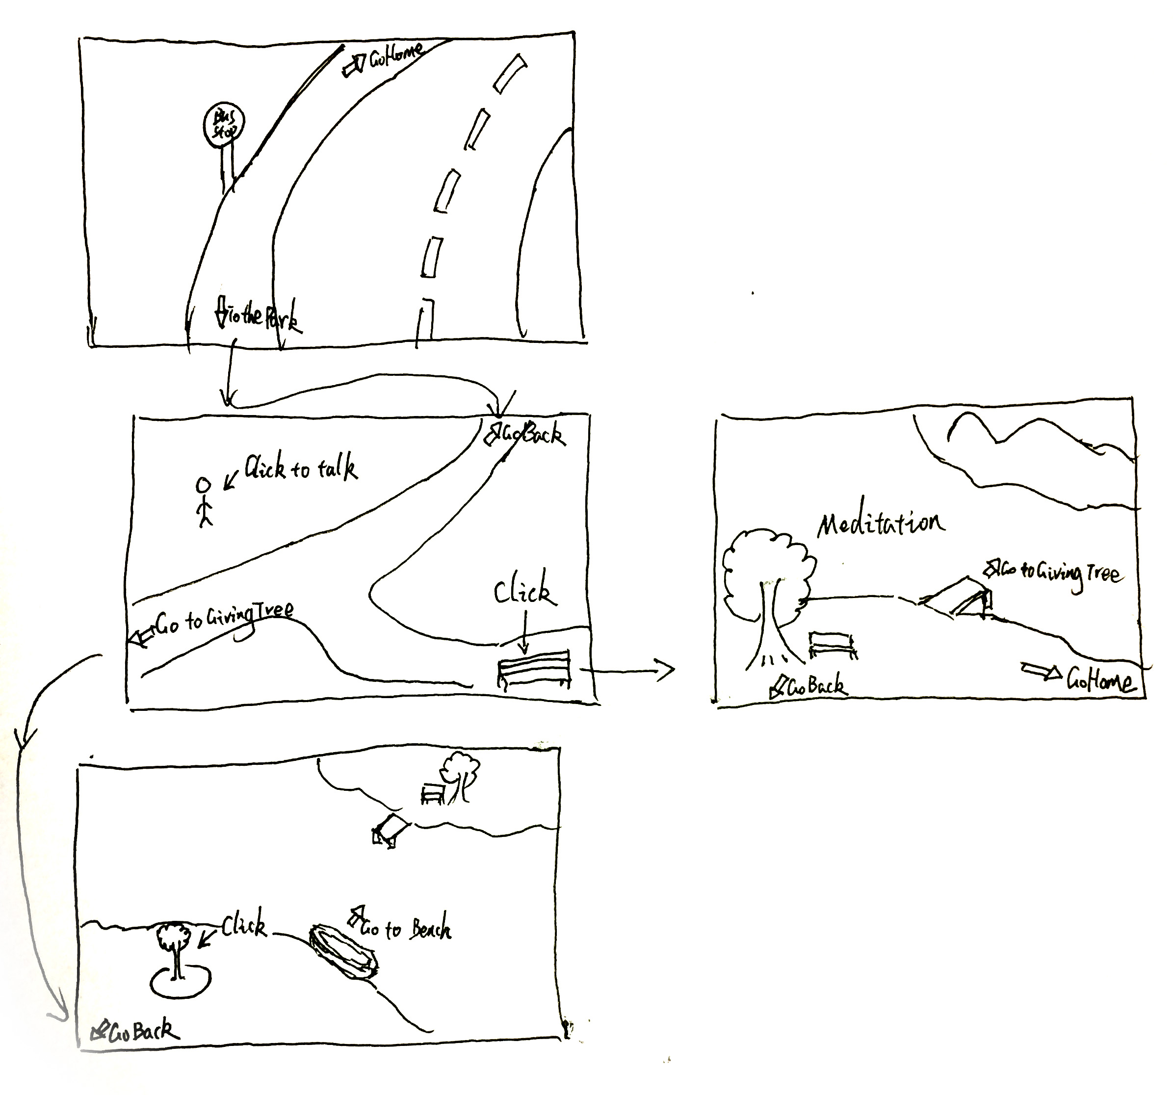

**6.4.6. Artistic Representation**

The artistic style of the park should be simple, watercolor-like, and clean. Player will need a good special environment to think about themselves, so they should not be disturbed by the environment.

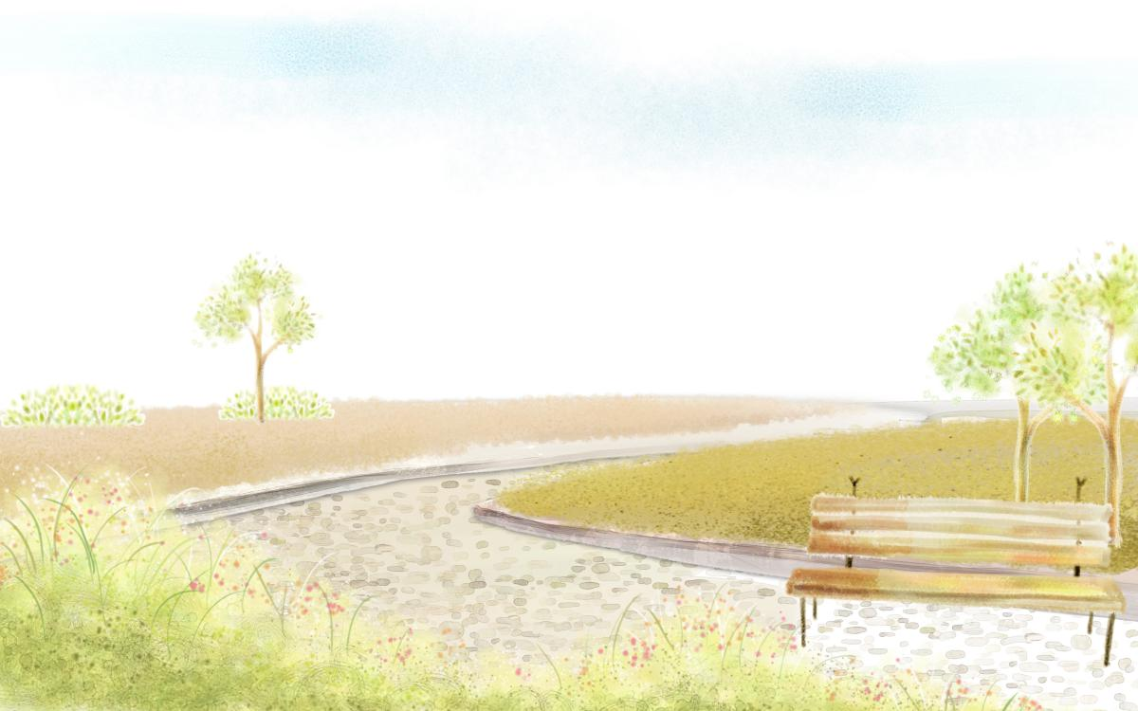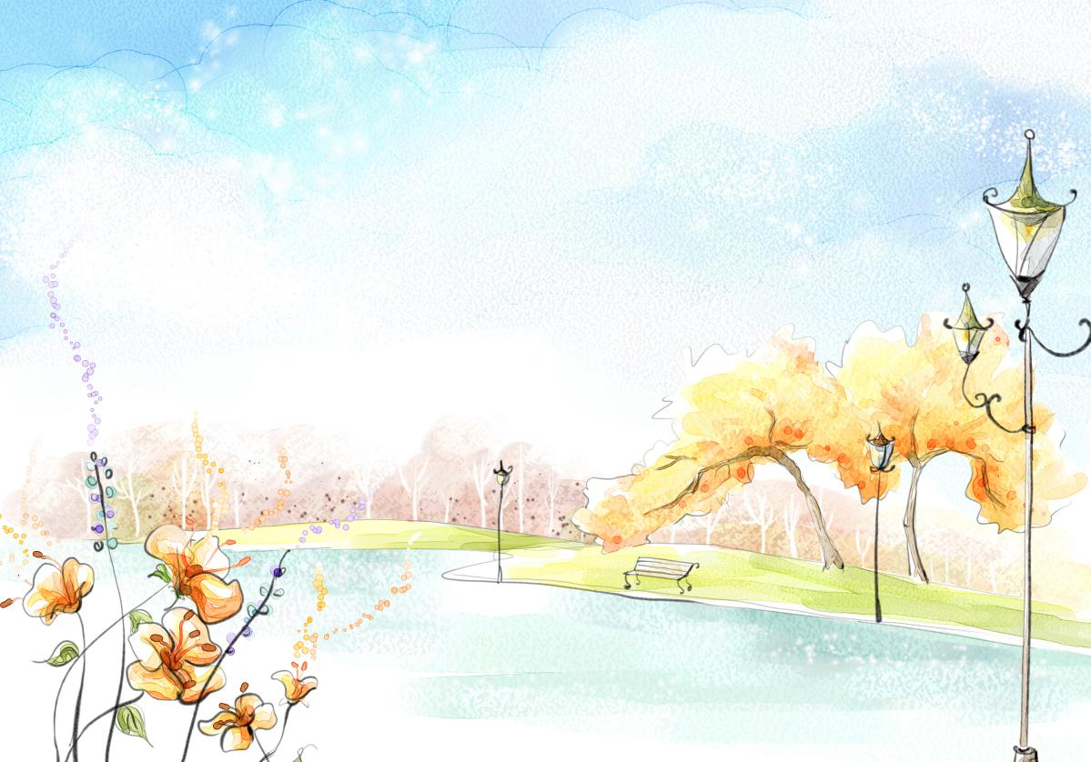

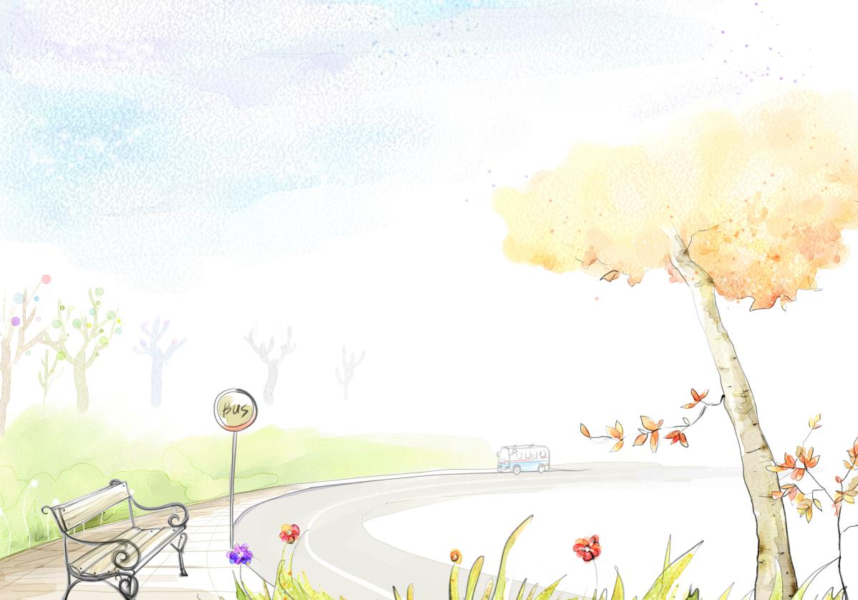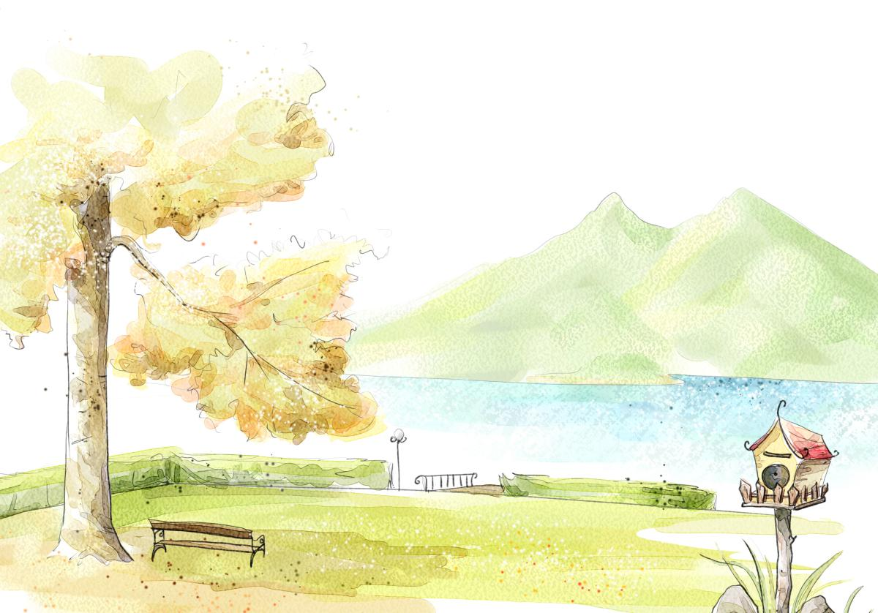

**6.4.7. Phased Development**

**6.4.7.1. Phase 1**

|  |  |  |
| --- | --- | --- |
| **Feature** | **Description** | **Priority** |
| **Park areas** | Different pictures of areas in the park, which can be connect together to form the park | Medium |
| **Meditation area** | A place for players to spend enough time to think, with beautiful view but few interruption | High |
| **Meditation audio** | Audios that can help players in meditation | High |

1. **4.7.2. Phase 2**

|  |  |  |
| --- | --- | --- |
| **Feature** | **Description** | **Priority** |
| **Animations** | Small actions that makes the park realistic | Medium |
| **Interactions** | Objects and NPCs that can be interacted with | Medium |
| **Companion** | Dialogues and audios for the companion | High |

**6.4.8. Additional Ideas and Possibilities**

* There could be more than one meditation area and could be more than one way for the refection.
* There could be more NPCs available in the park for the player to interact with.
* There could be a mayor who someday mentions the contribution of the player to the park as a reward/achievement.

**6.5. Grocery Store**

**6.5.1. Introduction**

The Grocery Store mini game is one of the last mini games presented to the player. It can be chosen after the player plays the Kitchen mini game, as the companion will suggest that after cooking the avatar needs to refill the shelves. It is part of the “resource management” mechanic offered by this game, alongside with the Kitchen mini game.

The first thing is to prepare a Grocery List. The player chooses between different types of products she wants to put in the list. After that, the actual mini game happens: it’s a catching game in which the avatar goes through the shelves selecting the items in their grocery list and avoiding items that are not on the list.

After successfully finishing the mini game, the game changes to a Cashier scene where the companion can praise the player and some social interaction (with NPCs) can be shown.

**6.5.2. Game Purpose**

The purpose of the grocery store mini game is to give the player some resource management and empowerment feeling. Besides the actual mini game, a lot of meaningful personal decisions are taken around this game.

**6.5.2.1. Experience**

Core experience: The feeling of empowerment brought by making decisions that are meaningful during the rest of the game

Before starting playing, the player needs to select between different types of supplies they’ll be searching for in the mini game. For example, if they put Milk in their Grocery List, they can choose between lactose-free, low fat and whole milk. When the mini game starts, she needs to catch the items she chose in the “list” phase.

After successfully finishing this game, the exact supplies chosen by the player appear in their kitchen, and can be used in recipes, which gives the feeling that all the choices made in the Grocery Store mini game are meaningful throughout the game. Also, in the cashier scene some social interaction can develop, and also praising can happen based on the player’s choices.

**6.5.3. Characters**

**6.5.3.1. Main Character**

**Name**: Player’s name

**Description**: Chosen by player. Subject to the art and animation style of the main game.

**Introduction**: The player is shown in all scenes of this mini game, especially in the “catching game” phase, since their hand is going to be shown as the “pointer”.

**Intention**: Adding the avatar to the game space is intended to add a feeling that the decisions taken by the player are taken by the avatar, so she feels closer to the avatar.

**6.5.3.2. Companion**

The companion will be in the upper left corner of the screen all the time, above the player’s avatar and out of the way for the game. The companion will introduce the concept of the game, walk the player through the steps of selecting the items, catching the supplies, praise the avatar at the end and be part of the social interaction on the cashier scene.

**6.5.3.3. NPCs**

* **NPC #1 – First neighbor (shown in the cashier scene)**
* **NPC #2 – Second neighbor (shown in the cashier scene)**

Please see the storyline for discussion of the NPCs’ contribution to the mini game.

**6.5.4. Core Mechanics**

This game is a catching game. The emphasis is on choice and empowerment. Those feelings come from the choices the player makes before playing the actual “catching game”, in the first scenes of the grocery store area.

**6.5.4.1. Controls**

All of the controls for this game will be completed using the left mouse button.

* Products Selection
  + Select between different types of supplies arranged by product (e.g. Milk, Eggs, Flour, separated in “Lactose Free Milk”, “Whole Milk”, and also in “Gluten Free Flour” or “Whole Flour”)
* Select item on shelf by clicking with mouse button

**6.5.4.2. Storyline**

This game always starts from the world map. The stories presented on this game are all parts of the main storyline. After the mini game, the companion and the cashier praise the player for their choices and some NPC dialog goes on.

**6.5.4.3. Storyboards**

Please note that representations of the companion and avatar were omitted from the storyboards for clarity.

* Opening transition: world map to grocery store.

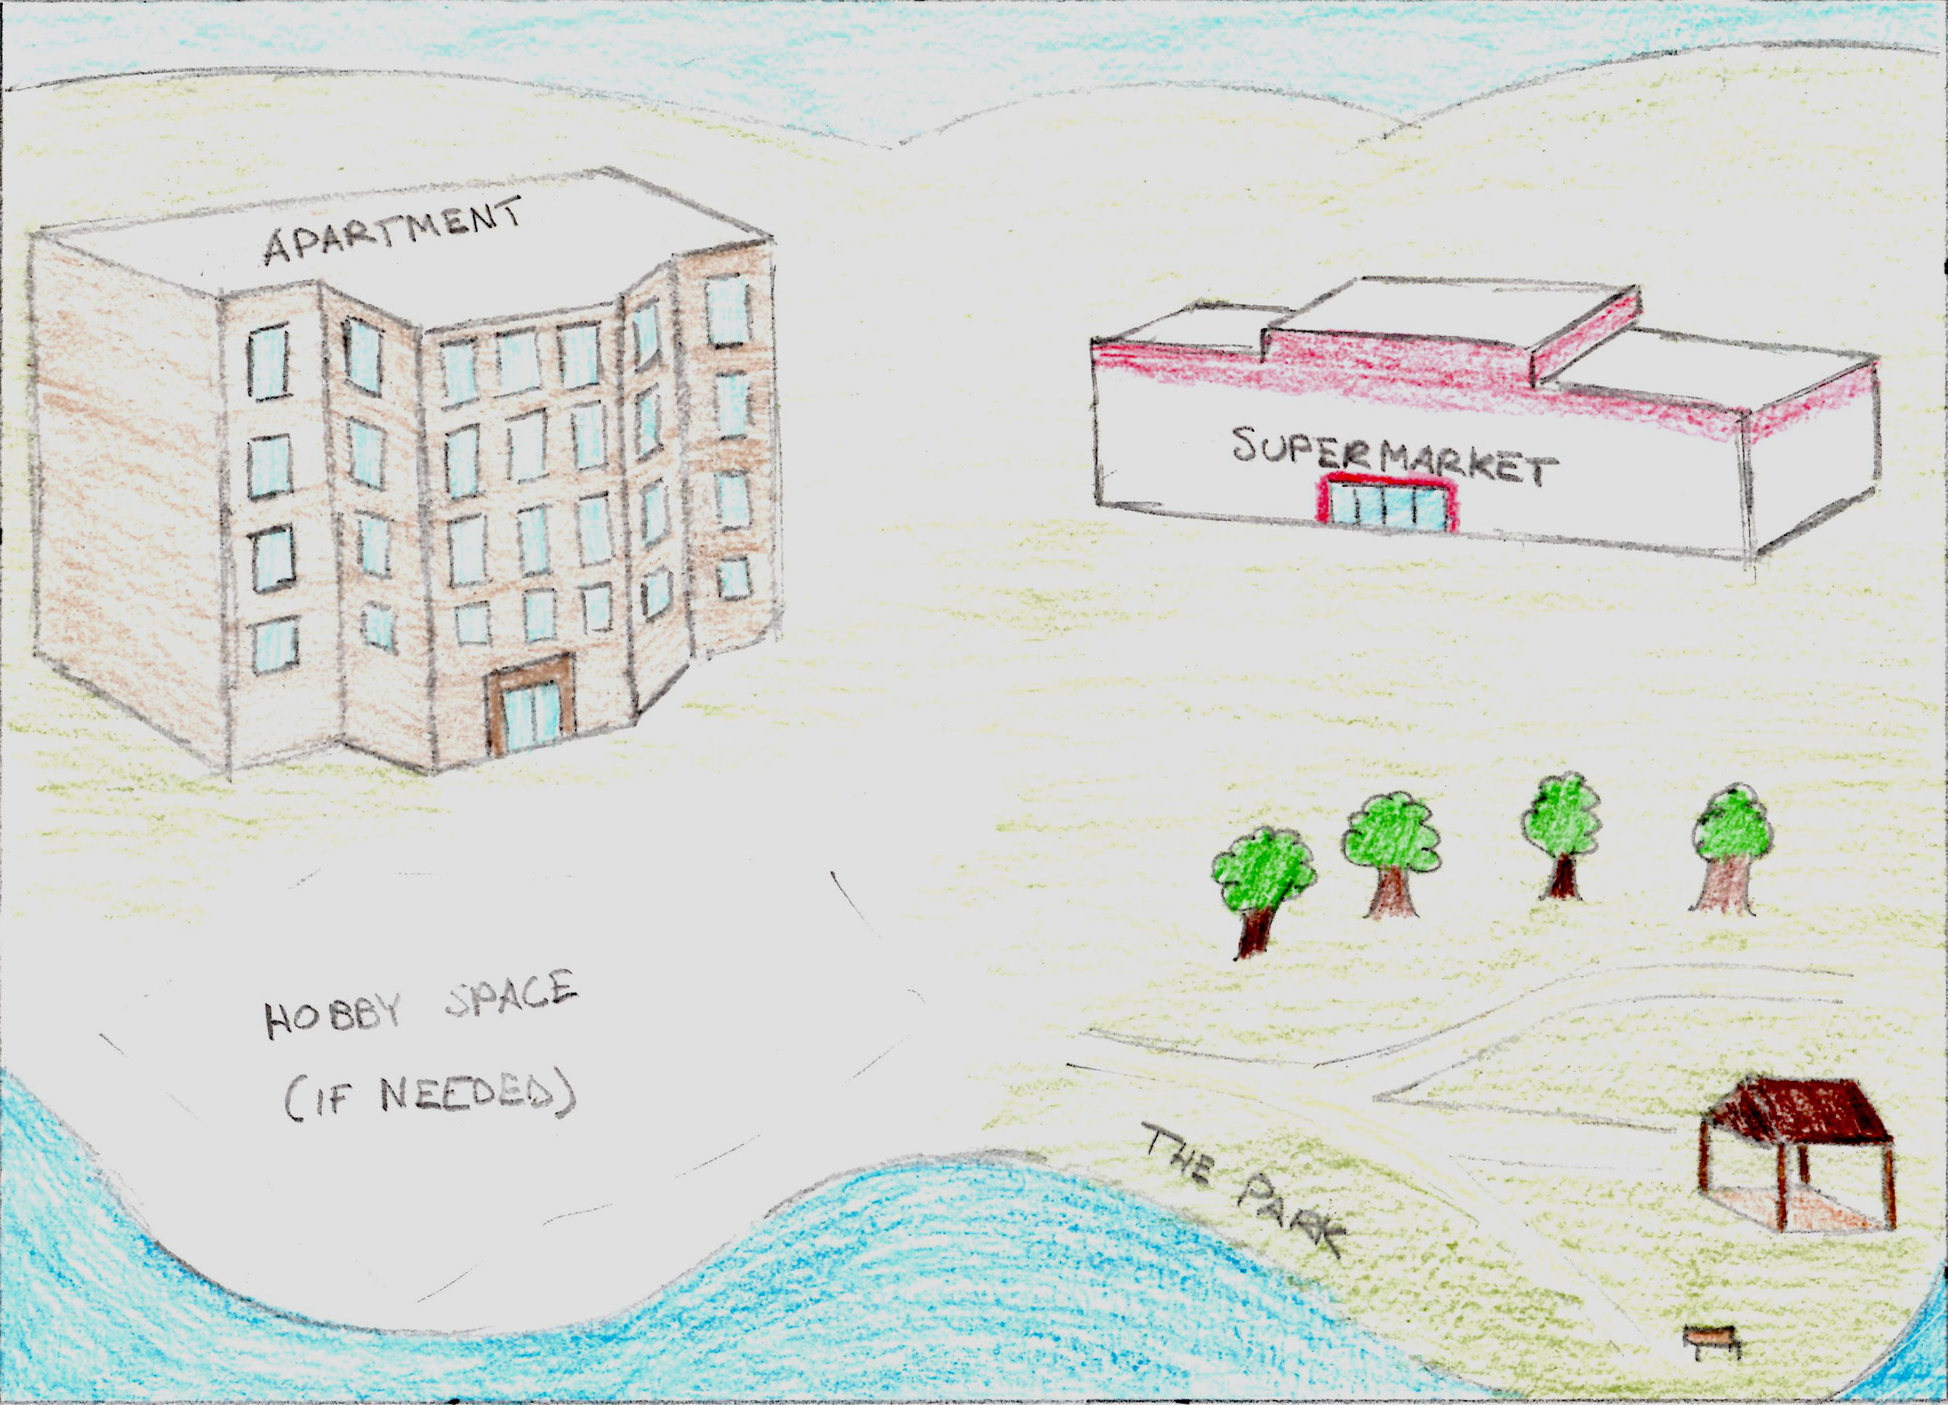 🡺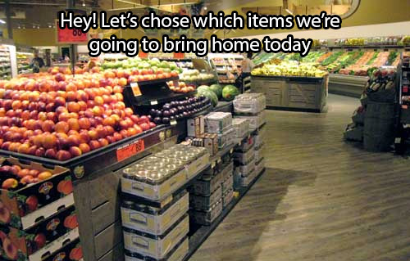

* Item selection popup dialog

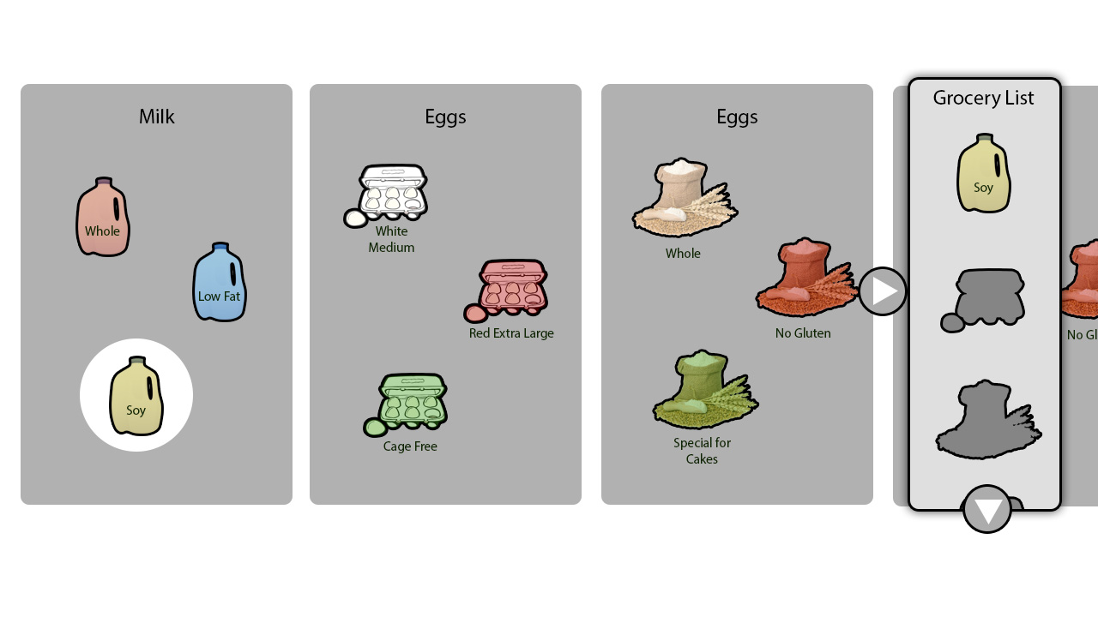

* Mini game gameplay.

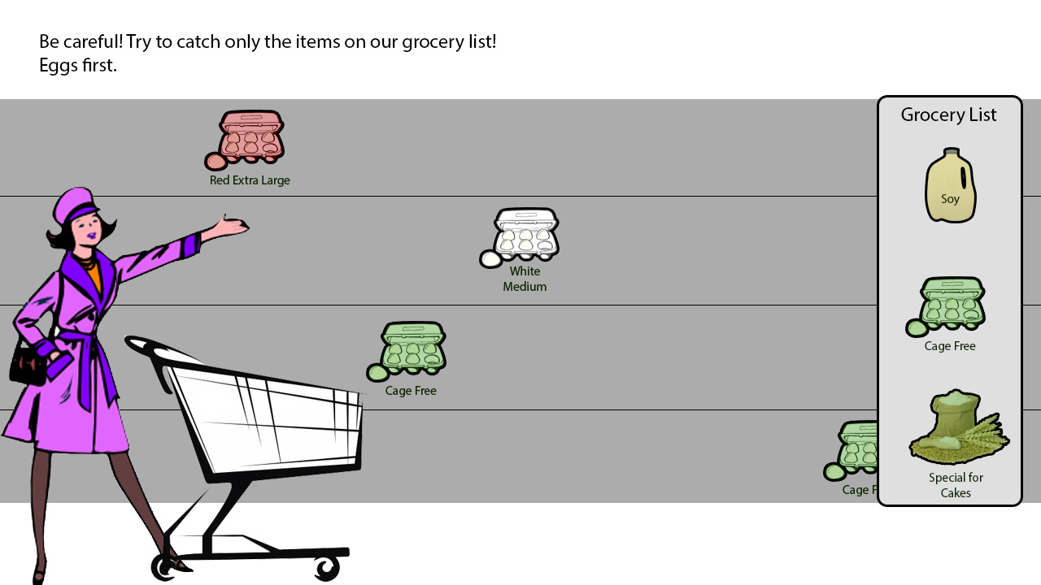

* Ending transition and interaction with the cashier and other customers

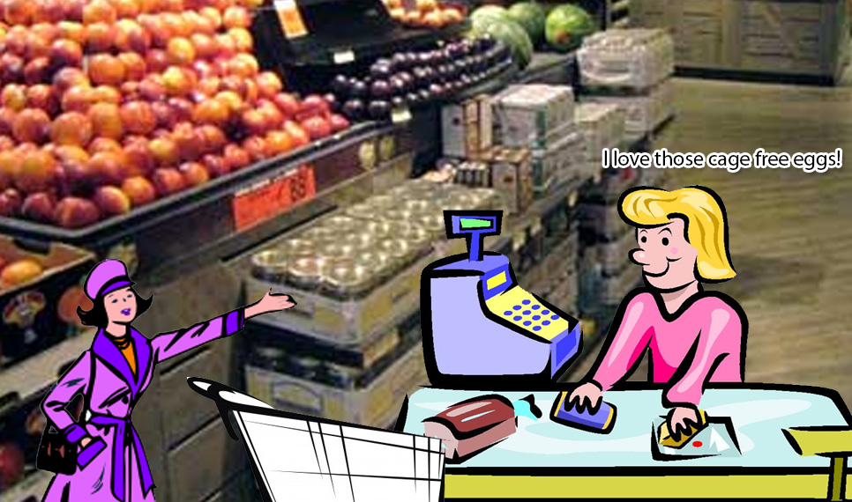

**6.5.4.4. Side Quests**

The side quests of this mini game are part of the games main side quests.

**6.5.4.5. Win Condition**

To win this game, the player needs to get 3 items of each of the previously selected items in the grocery list.

**6.5.4.6. Lose Condition**

If the player gets any item he didn’t put in the grocery list, he needs to start the mini game over again.

**6.5.4.7. Reward Mechanics**

The companion will respond favorably when the player is finished doing the groceries. These responses may be dialogue (including compliments or design-specific comments) or visual changes in the companion, if applicable.

Additionally, neighbor NPCs can appear in the cashier queue and praise the avatar’s choices, or even give them information about events happening in other areas.

As the player plays the game, sometimes they “unlock” new items in new levels. For example, level 2 unlocks Cage Free Eggs.

**6.5.5. Artistic Representation**

Please refer to the drafts shown in the Storyboards (Section 6.5.4.3) for artistic representation of the Grocery Store mini game.

**6.5.6. Levels**

Different amounts and options of items are given to the user when as the player has better performance on the “play-through” of this mini game. Refer to the examples of unlockable items listed:

|  |  |  |
| --- | --- | --- |
| Item Type | Variation | Level |
| Eggs | Red Extra Large | 1 |
| – | White Medium | 1 |
| – | Cage Free | 2 |
| Milk | Whole | 1 |
| – | Lactose Free | 1 |
| – | Low Fat | 2 |
| – | Soy | 3 |
| Flour | Wheat | 1 |
| – | Special For Cakes | 1 |
| – | Soy | 1 |
| – | Gluten Free | 3 |

Also, the amount of items stacked in the shelves increases, what will make the mini game harder to accomplish as the player progresses.

**6.5.7. Phased Development**

**6.5.7.1. Phase 1 (Base functionality)**

|  |  |  |
| --- | --- | --- |
| Feature | Description | Priority |
| Catching Mini Game | The gameplay mechanics of how the player is going to catch the grocery list items from the shelves. | High |
| Grocery List Selection | Player should be able to choose between different items before she starts to play the Catching game. | High |

**6.5.7.2. Phase 2 (Social Interaction)**

|  |  |  |
| --- | --- | --- |
| Feature | Description | Priority |
| Cashier Queue | After the successful accomplishment of the mini game, the player should have a dialog with the cashier. Also, she can meet NPCs like her neighbors in this part of the game. | High |

**6.5.7.3. Phase 3 (Integration)**

|  |  |  |
| --- | --- | --- |
| Feature | Description | Priority |
| Kitchen Integration | All items that are acquired in the Grocery Store are supposed to show up in the Kitchen, same type and variation chosen by the player. | Medium |
| Side Quest Integration | Side Quests must be integrated into the “Cashier” scene of this mini game | Low |

**7. Motivation**

**7.1. Short-Term Motivation**

* **Positive feedback:** After almost any action of the game the player will get positive feedback from the companion or NPCs. This feedback can be:
* A nice comment (what a nice dress! This looks really delicious…)
* A gift from an NPC (flowers, cookies…)
* **Mini games:** Most of the mini-games included are puzzle games such as kitchen mini game, TV show and magazine games… The scores and rewards attributed for winning a mini game can make the players motivated to play again.
* **Reward system:** The game has a complete reward system. Rewards are attributed after finishing a mini game or a side quest. Rewards can be:
* New furniture/clothes
* Badges (intermediate, master…)

**7.2. Mid-Term Motivation**

Mid-term motivation comes with the random events included that will note evolutions in the avatar life:

* Following the growth of the tree
* Getting a new job
* Introducing the puppy
* A new destination to visit
* Special date of the year (Christmas, Thanksgiving, Halloween…)

Unexpected events like these make the game surprising and the players excited to discover what will be the next step.

**7.3. Long-Term Motivation**

* Unlocking everything.
* Getting the best looking avatar.
* Feeling the empowerment.

**8. Phased Development**

**8.1. Phase 1 (Core)**

|  |  |  |
| --- | --- | --- |
| Feature | Description | Priority |
| Game Engine | The core of the Point & Click interaction in the game. The navigation and transition mechanics | High |
| House Navigation | The development of the main character’s house and it’s rooms still without mini games working | High |

**8.2. Phase 2 (Indoors Mini Games)**

|  |  |  |
| --- | --- | --- |
| Feature | Description | Priority |
| Bedroom Game | Development of the dress up mini game | High |
| Living Room Game | Development of the living room decoration mini game | High |
| Kitchen Game | Development of the kitchen mini game, and preparation for the integration with the Groceries mini game | High |

**8.3. Phase 3 (Outdoors Mini Games)**

|  |  |  |
| --- | --- | --- |
| Feature | Description | Priority |
| Grocery Store Game | Development of the groceries mini game | High |
| Park Game | Basic development of the Park mini game, with navigation between areas | High |
| Groceries-Kitchen Integration | Integration between the Kitchen and the Grocery Store. The items bought on the store should appear in the Kitchen the same way they show up in the Groceries. | Medium |

**8.3. Phase 4 (Wrap-up and Details)**

|  |  |  |
| --- | --- | --- |
| Feature | Description | Priority |
| Tree (Park) | Development of Tree Mini Game in the Park. | Medium |
| Meditation Sessions (Park) | Integration of the audio meditation sessions in the Meditation space in the park | Medium |
| Pet | Development of the Pet that will appear later on the game. It will appear on places around the house | Low |
| Groceries Improvement | Addition of “Tree Supplies” and “Pet Care” sections on the Grocery Store | Low |

**9. Future Development**

The game itself uses several mini-games aiding in the healing process for women coming out of battered relationships. However, we feel the game can be expanded to include more mini-games to provide alternative methods of similar healing processes. Each of the additional mini-games can apply clinically-approved healing and treatment processes to various scenarios in the game.

The game itself is designed by people who did not experience battered relationships. If the game were to be iterated upon after obtaining feedback from those that do experienced battered relationships, the game may change drastically depending on the feedback, which is to be expected.

Even though meditation games normally wouldn’t have long story plots, there are rooms for character development in non-playable character’s background, which the characters themselves may be involved in recovering from hardships faced from various sources of stress-related scenarios. If this is likely accepted, the game can then be expanded upon to provide the player more incentive to replay the game over and over by adding more similar design elements to the game, without incurring additional complexities.

We felt the concept is solid enough, and we are open to suggestions on improving upon it. By improving the game, more women of battered relationships can be recovered, healed, and can then return to their normal lives.